**CHAPTER-3**

**FORMULATION AND EVALUATION OF BINARY AND TERNARY COMPLEXES OF CLOPIDOGREL BISULPHATE AND DOLUTEGRAVIR SODIUM**

Extensive research work supports the understanding that cyclodextrins have the capacity to form molecular inclusion complexes and through the process of complex formation can alter the physico-chemical properties of the complexed drug molecules. The basic advantage in this process is that complexation with cyclodextrins alters the physico-chemical properties of the drug candidate without altering its pharmacological properties. It is now well established that complexation with cyclodextrins can alter properties of the drug such as solubility, dissolution rate, stability, palatability, and bioavailability. All these properties of the drug candidate are favourably affected. These complexing agents also have approvals from the regulatory agencies. Because of all these favourable qualities, cyclodextrins are being widely used in pharmaceutical formulation development.

Clopidogrel bisulphate is an antiplatelet drug. Its aqueous solubility is very low (0.0118µg/mL). It is known to have high permeability and is classified as a BCS class-II drug its molecular weight is 321.822 g/mol. Hence, it may be considered as a suitable drug candidate for inclusion complex formation. Cyclodextrin complexation was thus taken up with the objective of enhancing the aqueous solubility, dissolution rate and bioavailability of clopidogrel bisulphate.

Dolutegravir sodium is an anti-retroviral drug. Its aqueous solubility is very low (0.0922mg/mL). It has high permeability and is classified as BCS Class-II drug. Its molecular weight is 441.367 g/mol. This drug can also be considered as a suitable candidate for the formation of inclusion complexes, with the objective of enhancing its solubility, dissolution rate and bioavailability.

The studies carried out on complexation of clopidogrel bisulphate and dolutegravir sodium with β-CD and HP-β-CD are presented in this chapter. Further, the formation of ternary complexes of these two drugs with the CDS and hydrophilic polymers such as PVP K30, PEG 6000 and soluplus are also presented in this chapter.

**3.1. MATERIALS**

All the materials used in this work were of analytical grade and were used as received without any further treatment. The drugs and polymers used in this study are listed in **Table 3.1.1** along with their sources.

**Table 3.1.1: List of the materials used**

|  |  |  |
| --- | --- | --- |
| **S.NO** | **NAME OF THE CHEMICAL** | **SOURCE** |
| 1. | Clopidogrel bisulphate | Dr.Reddy’s Laboratory, Hyderabad |
| 2. | Dolutegravir sodium | Aurobindo Pharma, Hyderabad |
| 3. | β-CD | BMR Pharma, Hyderabad |
| 4. | HP-β-CD | BMR Pharma, Hyderabad |
| 5. | PVP K30 | Bayir Chemicals, Bangalore |
| 6. | PEG 6000 | Bayir Chemicals, Bangalore |
| 7. | Soluplus | BASF, Mumbai |

**3.2. PHASE SOLUBILITY STUDIES OF CBS AND DTG**

Phase solubility studies were performed according to the method reported by Higuchi and Connors1. An excess amount of the drug to be tested, i.e., CBS or DTG was individually added to 20 mL of double distilled water, taken in a stoppered conical flask. A series of stoppered conical flasks were taken to carry out these studies. Various concentrations of β-CD & HP-β-CD (2-12 mM) were added to the above series of conical flasks. The contents were shaken at room temperature (28±0.5ºC) for 72 hours on a rotary flask shaker. After 72 hours of shaking to achieve equilibrium, 2mL aliquots were withdrawn at one hour intervals and were filtered immediately using 0.45μ nylon disc filter. The filtered samples were diluted suitably and were assayed for CBS or DTG by measuring absorbance at 220 nm and 258 nm respectively against blanks prepared in the same concentration of β-CD &HP-β-CD in water, so as to cancel any absorbance that may be exhibited by the cyclodextrin molecules. Shaking was continued until three consecutive estimations were found to be the same.

Phase solubility studies were conducted in each case with and without the addition of hydrophilic polymers. In the series with hydrophilic polymers, the polymer was added at a concentration of 0.5% w/v to the solution containing CDs. The solubility experiments for both the drugs were conducted in triplicate. The apparent 1:1 stability constant (Kc) was calculated from the slope of the straight line of the phase solubility diagrams, according to the following equation:

KC=Slope/ S0 (1-Slope)

Where S0 is the intrinsic solubility of the drug

The phase solubility diagrams are shown in **Figure 3.2.1** to **3.2.4**, and in **Tables** **3.2.1** to **3.2.4.**

**3.3. PREPARATION OF SOLID INCLUSION COMPLEXES**

**3.3.1. Preparation of cyclodextrin complexes of CBS and DTG with and without hydrophilic polymers**

Solid inclusion complexes of CBS and DTG with β-CD; CBS and DTG with HP-β-CD alone and in combination with added hydrophilic polymers (PVP K30, PEG 6000 and soluplus) were studied for their dissolution rate and dissolution efficiency properties. The studies were carried out on solid inclusion complexes and the results obtained are described.

**Preparation of solid inclusion complexes**

Inclusion complexes were prepared for the two drugs, CBS and DTG, with two cyclodextrins, β-CD and HP-β-CD, using three techniques, namely, physical mixing, and kneading and solvent evaporation methods. It was found by carrying out drug content studies and dissolution rate studies that the complexes prepared by the kneading method were giving the best results. Hence, kneading method was used to prepare ternary complexes of the drugs. The ternary complexes contained a drug (CBS or DTG), a CD (β-CD or HP-β-CD) and a hydrophilic polymer (PVP K30 or PEG 6000 or Soluplus). These products contained complexes and hydrophilic polymers in the ratios of 1:1, 1:1.5, and 1:2.

**Physical mixing method:**

The physical mixture of respective ratios of CBS and DTG with CD was prepared by mixing the pulverized powder using a spatula5, 6.

**Kneading method:**

CBS and DTG were triturated separately with cyclodextrin and hydrophilic polymers in a mortar using a small volume of a solvent blend of water: methanol (1:1). The thick slurry formed was subjected to kneading for 45 min and was then dried at 55ºC until it was dry5, 7. The dried mass was powdered and sieved through Sieve no. 120# (particle size is less than or equal to 125 μm).

**Solvent evaporation method**

In this method, the physical mixture of the drug and the carrier were dissolved in a common solvent, which was evaporated until a clear, solvent free powder was left. The powder was further dried to constant weight. The first step in the solvent evaporation method was the preparation of a solution containing both matrix material and drug. The second step involves the removal of solvent(s) resulting in the formation of a solid dispersion. Mixing at the molecular level happens in this method and the method is preferred, because this leads to optimal dissolution properties5, 8.

Drug and the cyclodextrin mixture form the binary system and the addition of hydrophilic polymer to the D-CD complex forms the ternary mixture. Among the entire binary mixtures Drug-CD complex prepared by kneading method was found to be the best in enhancing the dissolution rate. Binary and ternary physical mixtures were kneaded vigorously for 1 hour using a small volume of water: methanol (1:1 v/v) solution to obtain a homogeneous dispersion. Products were then dried in the oven at the temperature of 55 0C for 45 minutes. The dried complex was pulverized into a fine state and was passed through Sieve # 120. **Tables 3.3.1.1** to **3.3.1.4** show the weighted ratios of drug-CD and drug-CD-hydrophilic polymers prepared by the described methods for binary and ternary mixtures along with their assigned codes.

**Table 3.3.1.1: Formulation codes for CBS- β-CD and HP-β-CD binary mixtures**

|  |  |  |  |
| --- | --- | --- | --- |
| **With β-CD** | | **With HP-β-CD** | |
| Complex system | Formulation code | Complex system | Formulation code |
| Pure drug | C |  |  |
| **Physical Mixture** | | **Physical Mixture** | |
| D:β-CD  (1:1) | C1 | D:HP-β-CD  (1:1) | C19 |
| D:β-CD  (1:1.5) | C2 | D:HP-β-CD  (1:1.5) | C20 |
| D:β-CD  (1:2) | C3 | D:HP-β-CD  (1:2) | C21 |
| **Kneading Method** | | **Kneading Method** | |
| D:β-CD  (1:1) | C4 | D:HP-β-CD  (1:1) | C22 |
| D:β-CD  (1:1.5) | C5 | D:HP-β-CD  (1:1.5) | C23 |
| D:β-CD  (1:2) | C6 | D:HP-β-CD  (1:2) | C24 |
| **Solvent Evaporation** | | **Solvent Evaporation** | |
| D:β-CD  (1:1) | C7 | D:HP-β-CD  (1:1) | C25 |
| D:β-CD  (1:1.5) | C8 | D:HP-β-CD  (1:1.5) | C26 |
| D:β-CD  (1:2) | C9 | D:HP-β-CD  (1:2) | C27 |

**Table 3.3.1.2: Formulation codes for CBS- β-CD and HP-β-CD ternary mixtures**

|  |  |  |  |
| --- | --- | --- | --- |
| **With Hydrophilic**  **polymers** | **Code** | **With Hydrophilic**  **polymers** | **Code** |
| D:β-CD:PVP K30  (1:1.5:1) | C10 | D:HP-β-CD:PVP K30  (1:1:1) | C28 |
| D:β-CD:PVP K30  (1:1.5:1.5) | C11 | D:HP-β-CD:PVP K30 (1:1:1.5) | C29 |
| D:β-CD:PVP K30  (1:1.5:2) | C12 | D:HP-β-CD:PVP K30  (1:1:2) | C30 |
| D:β-CD:PEG 6000  (1:1.5:1) | C13 | D:HP-β-CD:PEG 6000  (1:1:1) | C31 |
| D:β-CD:PEG 6000  (1:1.5:1.5) | C14 | D:HP-β-CD:PEG 6000  (1:1:1.5) | C32 |
| D:β-CD:PEG 6000  (1:1.5:2) | C15 | D:HP-β-CD:PEG 6000  (1:1:2) | C33 |
| D:β-CD:Soluplus  (1:1.5:1) | C16 | D:HP-β-CD: Soluplus  (1:1:1) | C34 |
| D:β-CD:Soluplus  (1:1.5:1.5) | C17 | D:HP-β-CD: Soluplus  (1:1:1.5) | C35 |
| D:β-CD:Soluplus  (1:1.5:2) | C18 | D:HP-β-CD: Soluplus  (1:1:2) | C36 |

**Table 3.3.1.3: Formulation codes for DTG-β-CD and DTG-HP-β-CD binary mixtures**

|  |  |  |  |
| --- | --- | --- | --- |
| **With β-CD** | | **With HP-β-CD** | |
| Complex system | Formulation code | Complex system | Formulation code |
| Pure drug | F |  |  |
| **Physical Mixture** | | **Physical Mixture** | |
| D:β-CD  (1:1) | F1 | D:HP-β-CD  (1:1) | F19 |
| D:β-CD  (1:1.5) | F2 | D:HP-β-CD  (1:1.5) | F20 |
| D:β-CD  (1:2) | F3 | D:HP-β-CD  (1:2) | F21 |
| **Kneading Method** | | **Kneading Method** | |
| D:β-CD  (1:1) | F4 | D:HP-β-CD  (1:1) | F22 |
| D:β-CD  (1:1.5) | F5 | D:HP-β-CD  (1:1.5) | F23 |
| D:β-CD  (1:2) | F6 | D:HP-β-CD  (1:2) | F24 |
| **Solvent Evaporation** | | **Solvent Evaporation** | |
| D:β-CD  (1:1) | F7 | D:HP-β-CD  (1:1) | F25 |
| D:β-CD  (1:1.5) | F8 | D:HP-β-CD  (1:1.5) | F26 |
| D:β-CD  (1:2) | F9 | D:HP-β-CD  (1:2) | F27 |

**Table 3.3.1.4: Formulation codes for DTG-β-CD and DTG-HP-β-CD ternary mixtures**

|  |  |  |  |
| --- | --- | --- | --- |
| **With Hydrophilic**  **polymers** | **Code** | **With Hydrophilic**  **polymers** | **Code** |
| D:β-CD:PVP K30  (1:1.5:1) | F10 | D:HP-β-CD:PVP K30  (1:2:1) | F28 |
| D:β-CD:PVP K30  (1:1.5:1.5) | F11 | D:HP-β-CD:PVP K30  (1:2:1.5) | F29 |
| D:β-CD:PVP K30  (1:1.5:2) | F12 | D:HP-β-CD:PVP K30  (1:2:2) | F30 |
| D:β-CD:PEG 6000  (1:1.5:1) | F13 | D:HP-β-CD:PEG 6000  (1:2:1) | F31 |
| D:β-CD:PEG 6000  (1:1.5:1.5) | F14 | D:HP-β-CD:PEG 6000  (1:2:1.5) | F32 |
| D:β-CD:PEG 6000  (1:1.5:2) | F15 | D:HP-β-CD:PEG 6000  (1:2:2) | F33 |
| D:β-CD:Soluplus  (1:1.5:1) | F16 | D:HP-β-CD: Soluplus  (1:2:1) | F34 |
| D:β-CD:Soluplus  (1:1.5:1.5) | F17 | D:HP-β-CD: Soluplus  (1:2:1.5) | F35 |
| D:β-CD:Soluplus  (1:1.5:2) | F18 | D:HP-β-CD: Soluplus  (1:2:2) | F36 |

**3.4. PHYSICO CHEMICAL CHARACTERIZATION OF CBS AND DTG**

Physico chemical characterization of CBS and DTG were performed by the following methods:

3.4.1. Differential scanning calorimetry

3.4.2. Powder X-ray diffraction

3.4.3. Scanning electron microscopy

3.4.4. Fourier transform infra red spectroscopy studies

**3.4.1 Differential scanning calorimetry**

Conventional differential scanning calorimetry(DSC) and modulated temperature differential scanning calorimetry (MTDSC) experiments were performed using DSC Q200 (TA Instruments, NJ, USA) with a refrigerated cooling assembly (RCS) and a modulated capability. The DSC cell was purged with 50mL/min dry nitrogen, and the RCS was purged with 150 mL/min nitrogen. The DSC cell was calibrated for baseline using empty pans of matched weight and for temperature using three temperature standards (cyclohexane, Tm=279.54ºK; indium, Tm=429.61ºK; tin, Tm=504.93ºK). A known mass of sample (3-5 mg) was placed in a hermetically sealed aluminium pan and exposed to heating rate of 100C/min under dry nitrogen purging (50mL/min) from the desired starting temperature to above melting points of CBS or of DTG. The data was analyzed using Universal Analysis Software from Instruments, NJ, and USA2, 3.

**3.4.2 Powder X-ray diffraction**

Powder X-ray diffraction (p-XRD) patterns of CBS and DTG were recorded using Burkeraxs D-8 (Advance, Germany) powder diffractometry with monochromatized Cu Kα radiation (λ=1.540600), at a voltage of 40KV. The solid inclusion complexes prepared were scanned at room temperature in the continuous scan mode over the 2θ angle range of 5 to 60º, with 0.1 θ step size and with counting time of 1.0 sec2, 3.

**3.4.3 Scanning electron microscopy**

Surface morphology was examined by JEOL JSM-6400 (Jeol Ltd., Tokyo, Japan) scanning electron microscope (SEM). The samples of the drugs were coated with gold, using sputtering technique, and the gold-coated samples were viewed for surface topography in SEM at an acceleration voltage of 10 KV at ×150 and ×500 magnifications3.

**3.4.4. Fourier Transform Infra Red spectroscopy studies**

The drug, the polymers and the solid dispersions prepared were examined by FTIR spectroscopy using Perkin-Elmer [model: Spectrum 65 (C85069) UK] in diffused reflectance mode. Two to three mg of samples were taken, triturated well with potassium bromide (100 mg) and were placed in the sample holder. The samples were scanned in the region of 4,000 to 450 cm-1 with acquisition single sided at a spectral resolution of 4 cm-1. Each spectrum was derived from 16 single average scans for two zero fittings4.

**3.5. EVALUATION OF BINARY AND TERNARY MIXTURES**

**3.5.1. Drug content uniformity**

An accurately weighed quantity of a complex system prepared was transferred to a 100 mL volumetric flask. To this powder, a few mL of methanol was added and the solution was mixed thoroughly to dissolve the contents. The solution was made up to 100mL with methanol and it was further suitably diluted with pH 6.8 phosphate buffer and the absorbances were measured at 220nm and 258nm respectively for CBS and DTG. All the experiments were carried out in triplicate4, 9**.**

**3.5.2. Dissolution rate study**

The dissolution rate of CBS and DTG as such and from their CD inclusion complexes was studied using DISSO 2000, Lab India 8-station dissolution rate USP II test apparatus. These studies were carried out as per the procedures reported in literature11,12.

The dissolution was performed using 900mL of 0.1 N HCl solution (pH 1.2) and pH 6.8 phosphate buffer containing 0.5% SLS as dissolution media maintained at 37±0.5 ºC and 50 rpm. Samples of dissolution medium (5mL) were withdrawn through 0.45μ nylon disc filter at different time intervals, suitably diluted and assayed for CBS and DTG respectively by measuring absorbance at 220 nm and 258 nm for 120 minutes in 0.1 N HCl and 80 minutes in pH 6.8 phosphate buffer solution and replaced with fresh dissolution medium to maintain sink condition. The dissolution of CBS and DTG in two media was examined in order to see which one is suitable for dissolving them. The dissolution results showed a significant difference in the dissolution profile for both the drugs, the % drug released was almost 100% after 120 minutes in 0.1 N HCl while in phosphate buffer the % released was 100% after 80 minutes.

The dissolution results in two media demonstrate that pH 6.8 phosphate buffer was best for further dissolution studies with the addition of hydrophilic polymers and 0.1 N HCl was least suitable. The dissolution studies were carried out in triplicate4and the parameters are tabulated in **Table 3.5.2.1.**

**Table 3.5.2.1: Dissolution parametres**

|  |  |
| --- | --- |
| Type of Apparatus | Type II |
| Buffer | (0.1 N HCl/ pH 6.8 Phosphate buffer) containing 0.5% SLS |
| Buffer volume | 900mL |
| RPM | 50 |
| Temperature | 37±1ºC |
| Volume of sample | 5 mL |
| CBS λmax | 220nm |
| DTG λmax | 258 nm |

**3.5.3. Dissolution efficiency**

Dissolution efficiency (DE) is another parameter suitable for the evaluation of *in vitro* dissolution data. DE is defined as the area under the dissolution curve up to a certain time ‘t’ expressed as a percentage of the area of the rectangle described by 100% dissolution at the same time.

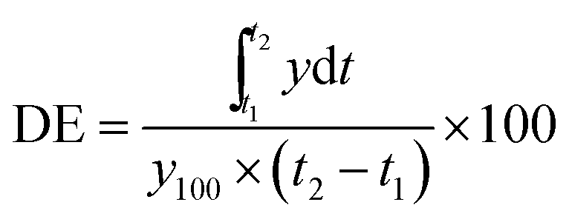

The dissolution efficiency can have a range of values depending on the time intervals chosen. In any case, constant time intervals should be chosen for comparison. For example, DE30 would relate to the dissolution of the drug from a particular formulation after 30 minutes and could only be compared with DE30 of other formulations. Summation of the large dissolution data into a single figure DE enables ready comparison to be made between a large numbers of formulations. The second advantage is that it can be theoretically related to the *in vivo* data. Since *in vivo* drug availability is estimated by integrating the area under blood level curve it seems reasonable to express *in vitro* results similarly. Also, when a relation is to be shown between dissolution and another variable, it is perhaps more realistic to use dissolution efficiency which takes into account the dissolution profile as a whole , as opposed to T50% or T90% values which use just one point from the plot. Dissolution efficiency (DE30) values were calculated as per Khan10. T50 (time taken for 50% dissolution) values were recorded from the dissolution profiles.

**3.6. RESULTS**

**PHASE SOLUBILITY STUDIES RESULTS**

The solubility of clopidogrel bisulphate in water containing various concentration of β-CD (0-12 mM) and HP- β-CD (0-12 mM) alone and in the presence of hydrophilic polymers (% W/V) are given in **Table 3.2.1** & **3.2.2** and their respective phase solubility diagrams are shown in **Figure 3.2.1** & **3.2.2.**

**Table 3.2.1: Solubility of clopidogrel bisulphate in water containing various concentration of β-CD alone and in the presence of hydrophilic polymers**

|  |  |  |  |  |
| --- | --- | --- | --- | --- |
| **Concentration**  **of β CD (mM)** | **Concentration of clopidogrel bisulphate (mM)** | | | |
| **Without polymer** | **In the presence of 0.5 % W/V** | | |
| **PEG 6000** | **PVP K30** | **SOLUPLUS** |
| 0 | 0.0059 | 0.0061 | 0.0084 | 0.0090 |
| 2 | 0.0078 | 0.0079 | 0.0129 | 0.0149 |
| 4 | 0.0088 | 0.0099 | 0.0185 | 0.0234 |
| 6 | 0.0116 | 0.0166 | 0.0235 | 0.0286 |
| 8 | 0.0139 | 0.0188 | 0.0286 | 0.0336 |
| 10 | 0.0158 | 0.0229 | 0.0325 | 0.0376 |
| 12 | 0.0163 | 0.0285 | 0.0395 | 0.0462 |

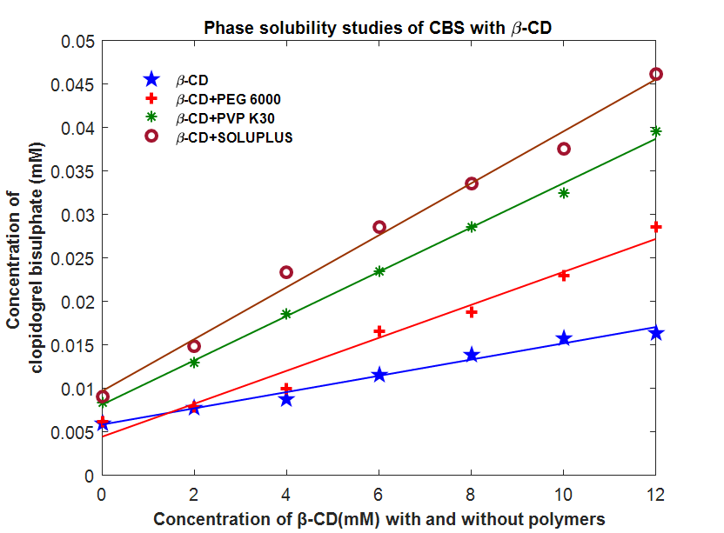

**Figure 3.2.1: Phase solubility studies of CBS- β-CD complexation with and without the inclusionof hydrophilic polymers**

**Table 3.2.2: Solubility of clopidogrel bisulphate in water containing various concentration of HP-β-CD alone and in the presence of hydrophilic polymers**

|  |  |  |  |  |
| --- | --- | --- | --- | --- |
| **Concentration of HP-β-CD (mM)** | **Concentration of clopidogrel bisulphate (mM)** | | | |
| **Without polymer** | **In the presence of 0.5 % W/V** | | |
| **PEG 6000** | **PVP K30** | **SOLUPLUS** |
| 0 | 0.0060 | 0.0078 | 0.0092 | 0.0099 |
| 2 | 0.0087 | 0.0091 | 0.0139 | 0.0159 |
| 4 | 0.0099 | 0.0122 | 0.0199 | 0.0264 |
| 6 | 0.0122 | 0.0186 | 0.0245 | 0.0366 |
| 8 | 0.0143 | 0.0208 | 0.0296 | 0.0387 |
| 10 | 0.0166 | 0.0249 | 0.0377 | 0.0456 |
| 12 | 0.0181 | 0.0305 | 0.0412 | 0.0498 |

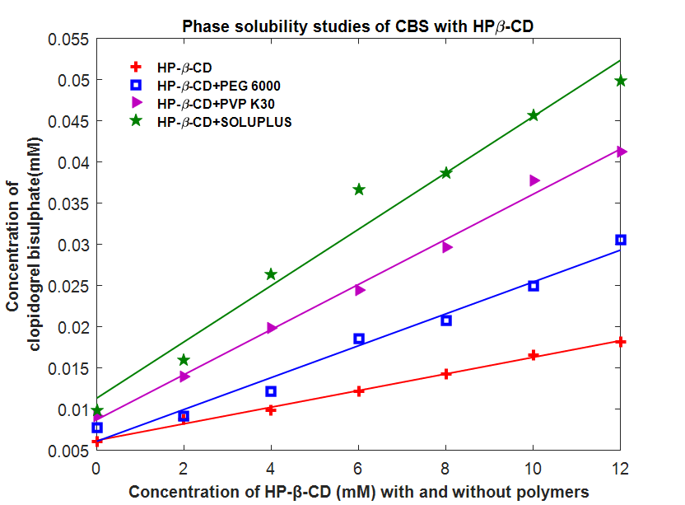

**Figure 3.2.2: Phase solubility studies of CBS-HP- β-CD complexation with and without inclusion of hydrophilic polymers**

The solubility of dolutegravir sodium in water containing various concentration of β-CD (0-12 mM) and HP-β-CD (0-12 mM) alone and in the presence of hydrophilic polymers (% W/V) are given in **Table 3.2.3** and **3.2.4** and their respective phase solubility diagrams are shown in **Figure 3.2.3** and **3.2.4.**

**Table 3.2.3: Solubility of dolutegravir sodium in water containing various concentration of β-CD alone and in the presence of hydrophilic polymers**

|  |  |  |  |  |
| --- | --- | --- | --- | --- |
| **Concentration of β-CD (mM)** | **Concentration of dolutegravir sodium (mM)** | | | |
| **Without polymer** | **In the presence of 0.5 % W/V** | | |
| **PEG 6000** | **PVP K30** | **SOLUPLUS** |
| 0 | 0.0055 | 0.0058 | 0.0064 | 0.0075 |
| 2 | 0.0065 | 0.0067 | 0.0118 | 0.0141 |
| 4 | 0.0072 | 0.0097 | 0.0171 | 0.0205 |
| 6 | 0.0107 | 0.0134 | 0.0202 | 0.0273 |
| 8 | 0.0142 | 0.0165 | 0.0269 | 0.0329 |
| 10 | 0.0167 | 0.0181 | 0.0287 | 0.0374 |
| 12 | 0.0206 | 0.0259 | 0.0360 | 0.0436 |

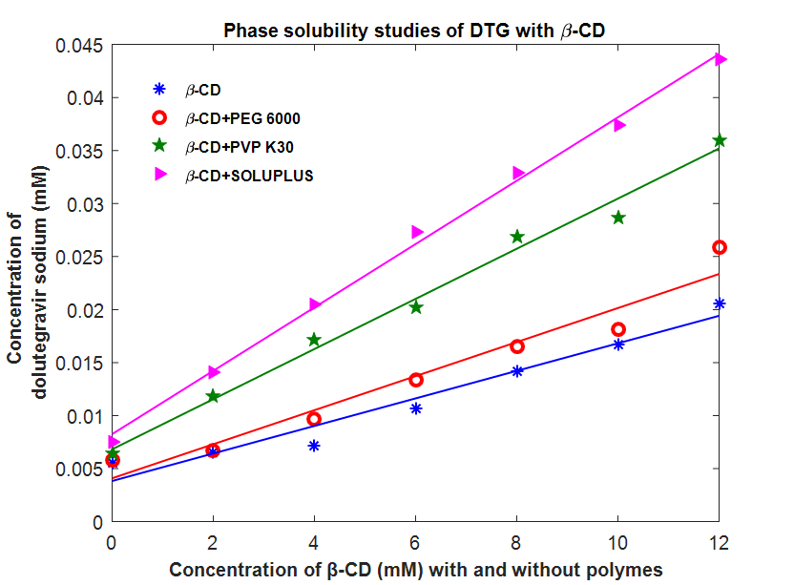

**Figure 3.2.3: Phase solubility studies of DTG- β-CD complexation with and without inclusion of hydrophilic polymers**

**Table 3.2.4: Solubility of dolutegravir sodium in water containing various concentration of HP-β-CD alone and in the presence of hydrophilic polymers.**

|  |  |  |  |  |
| --- | --- | --- | --- | --- |
| **Concentration of HP-β-CD (mM)** | **Concentration of dolutegravir sodium (mM)** | | | |
| **Without polymer** | **In the presence of 0.5 % W/V** | | |
| **PEG 6000** | **PVP K30** | **SOLUPLUS** |
| 0 | 0.0056 | 0.0063 | 0.0072 | 0.0087 |
| 2 | 0.0069 | 0.0076 | 0.0119 | 0.0147 |
| 4 | 0.0081 | 0.0107 | 0.0179 | 0.0252 |
| 6 | 0.0112 | 0.0171 | 0.0225 | 0.0354 |
| 8 | 0.0144 | 0.0193 | 0.0276 | 0.0478 |
| 10 | 0.0179 | 0.0234 | 0.0357 | 0.0547 |
| 12 | 0.0215 | 0.0290 | 0.0392 | 0.0589 |

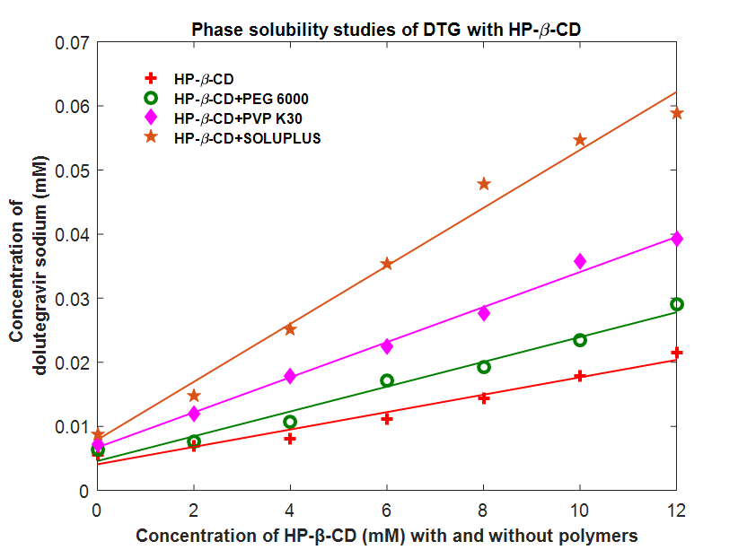

**Figure 3.2.4: Phase solubility studies of DTG-HP-β-CD complexation with and without inclusion of hydrophilic polymers**

The calculated apparent solubility constants of various CBS-CD and DTG-CD complexes systems and their complexation efficiency are given in **Table 3.2.5**.

**Table 3.2.5: Apparent solubility constants of various CBS-CD and DTG-CD complexes systems**

|  |  |  |
| --- | --- | --- |
| Complex system | Kc (M-1) | Complexation efficiency  (no. of folds of increase in Kc) |
| **CBS** | | |
| CBS- β-CD | 161 | - |
| CBS- β-CD-PEG 6000 | 256 | 1.59 |
| CBS- β-CD-PVP K30 | 326 | 2.02 |
| CBS- β-CD-SOLUPLUS | 404 | 2.50 |
| CBS-HP-β-CD | 169 | - |
| CBS-HP-β-CD-PEG 6000 | 327 | 1.93 |
| CBS- HP-β-CD-PVP K30 | 357 | 2.11 |
| CBS- HP-β-CD-SOLUPLUS | 444 | 2.62 |
| **DTG** | | |
| DTG- β-CD | 181 | - |
| DTG- β-CD-PEG 6000 | 317 | 1.75 |
| DTG- β-CD-PVP K30 | 416 | 2.29 |
| DTG- β-CD-SOLUPLUS | 459 | 2.53 |
| DTG-HP-β-CD | 185 | - |
| DTG-HP-β-CD-PEG 6000 | 344 | 1.85 |
| DTG- HP-β-CD-PVP K30 | 468 | 2.59 |
| DTG- HP-β-CD-SOLUPLUS | 533 | 2.88 |

The solubilising efficiencies and the effect of cyclodextrins and CD-hydrophilic polymers on the solubility of CBS and DTG are given in **Table 4.1.6**.

**Table 3.2.6: Effect of cyclodextrins and CD-hydrophilic polymers on the solubility of CBS and DTG and their solubilising efficiencies**

|  |  |  |  |
| --- | --- | --- | --- |
| Complex system | Solubility of CBS (mM) in | | |
| Water | CD solution (12 mM) | *Solubilising efficiency |
| **CBS** | | | |
| CBS | 0.0059 | - | - |
| CBS- β-CD | - | 0.0163 | 2.76 |
| CBS- β-CD-PEG 6000 | - | 0.0285 | 4.83 |
| CBS- β-CD-PVP K30 | - | 0.0395 | 6.69 |
| CBS- β-CD-SOLUPLUS | - | 0.0462 | 7.83 |
| CBS-HP-β-CD | - | 0.0181 | 3.06 |
| CBS-HP-β-CD-PEG 6000 | - | 0.0305 | 5.16 |
| CBS- HP-β-CD-PPV K30 | - | 0.0412 | 6.98 |
| CBS- HP-β-CD-SOLUPLUS | - | 0.0498 | 8.44 |
| **DTG** | | | |
| DTG | 0.0055 | - | - |
| DTG- β-CD | - | 0.0206 | 3.74 |
| DTG- β-CD-PEG 6000 | - | 0.0259 | 4.70 |
| DTG- β-CD-PVP K30 | - | 0.0360 | 6.54 |
| DTG- β-CD-SOLUPLUS | - | 0.0436 | 7.92 |
| DTG-HP-β-CD | - | 0.0215 | 3.90 |
| DTG-HP-β-CD-PEG 6000 | - | 0.0290 | 5.27 |
| DTG- HP-β-CD-PVP K30 | - | 0.0392 | 7.12 |
| DTG- HP-β-CD-SOLUPLUS | - | 0.0589 | 10.70 |

*Ratio between drug solubility in aqueous solution (12mM) of CD (with and without hydrophilic polymers) and in water.

**PHYSICO-CHEMICAL CHARACTERIZATION OF BINARY AND TERNARY MIXTURES**

**DSC STUDIES**

The compatibility of drug and excipients was evaluated by DSC. DSC was used to characterize the CBS-CD’s and DTG-CD’s solid complexes prepared with and without hydrophilic polymers and are discussed in the following sections:

* DSC studies of CBS
* DSC studies of DTG

**DSC studies of CBS**

The DSC thermograms of CBS and its CD-complexes are shown in **Figure 3.4.1.1.1 to 3.4.1.1.2** and their fractional crystallinity [(ΔHf) sample/ (ΔHf) crystal] values are given in **Table 3.4.1.1**

**(A)**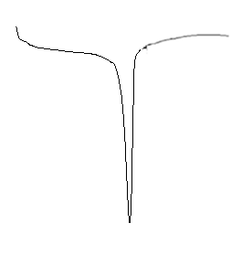

**(B)**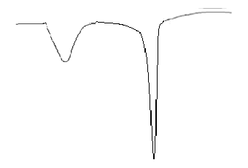

**(C)**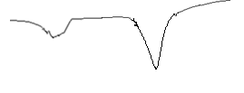

**(D)**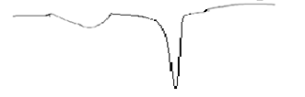

**(E)**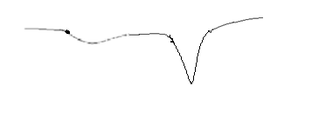



**Figure 3.4.1.1.1: DSC graphs of (A)CBS, (B)CBS-β-CD, (C)CBS- β-CD-PVP K30, (D)CBS-β-CD-PEG 6000 and (E)CBS-β-CD-soluplus**

**(A)**

**(B)**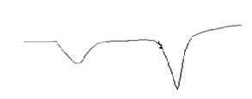

**(C)**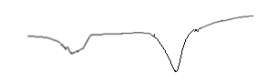

**(D)**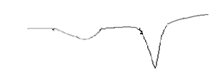

**(E)**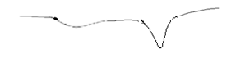



**Figure 3.4.1.1.2: DSC graphs of (A) CBS, (B)CBS-HP-β-CD, (C)CBS-HP-β-CD-PVP K30, (D)CBS-HP-β-CD-PEG 6000 and (E)CBS-β-CD-soluplus**

**Table 3.4.1.1: DSC studies of CBS-binary and ternary complex systems**

|  |  |  |  |
| --- | --- | --- | --- |
| **Product** | **DSC** | | **Fractional crystallinity (%)** |
| **ΔTpeak(0C)** | **ΔHfusion(J/g)** |
| Clopidogrel bisulphate | 160.48 | 64.14 | - |
| CBS-β-CD | 156.7 | 49.44 | 77.08 |
| CBS-β-CD-PEG 6000 | 152.5 | 43.54 | 67.89 |
| CBS-β-CD-PVP K30 | 144.1 | 39.25 | 61.20 |
| CBS-β-CD-SOLUPLUS | 140.3 | 31.00 | 48.33 |
| CBS-HP-β-CD | 153.2 | 44.75 | 69.77 |
| CBS-HP-β-CD-PEG 6000 | 141.6 | 37.26 | 58.10 |
| CBS-HP-β-CD-PVP K30 | 136.54 | 32.87 | 51.20 |
| CBS-HP-β-CD-SOLUPLUS | 130.12 | 28.59 | 44.57 |

**DSC studies of DTG**

The DSC thermograms of DTG and its CD-complexes are shown in **Figure 3.4.1.2.1** to **3.4.1.2.2** and their fractional crystallinity [(ΔHf) sample/ (ΔHf) crystal] values are given in **Table 3.4.1.2**

**(A)**

**(B)** 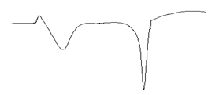

**(C)**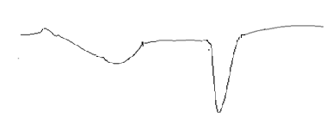

**(D)**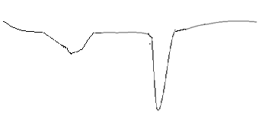

**(E)**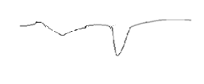



**Figure 3.4.1.2.1: DSC graphs of (A) DTG, (B) DTG-β-CD, (C) DTG-β-CD-PVP K30, (D) DTG-β-CD-PEG 6000 and (E) DTG-β-CD-soluplus**

**(A)**

**(B)**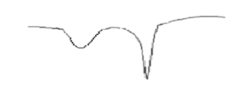

**(C)**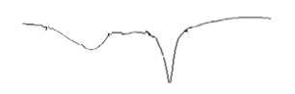

**(D)**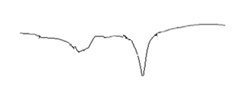

**(E)**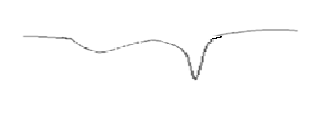



**Figure 3.4.1.2.2: DSC graphs of (A)DTG,(B) DTG-HP-β-CD, (C)DTG-HP-β-CD-PVP K30, (D)DTG-HP-β-CD-PEG 6000 and (E)DTG-HP-β-CD-soluplus**

**Table 3.4.1.2: DSC studies of DTG-binary and ternary complex systems**

|  |  |  |  |
| --- | --- | --- | --- |
| **Product** | **DSC** | | **Fractional crystallinity (%)** |
| **ΔTpeak(0C)** | **ΔHfusion(J/g)** |
| Dolutegravir sodium | 196 | 71.40 | - |
| DTG-β-CD | 188.13 | 56.16 | 78.65 |
| DTG-β-CD-PEG 6000 | 182.3 | 49.27 | 69.00 |
| DTG-β-CD-PVP K30 | 175.4 | 38.15 | 53.43 |
| DTG-β-CD-SOLUPLUS | 167.2 | 31.28 | 43.80 |
| DTG-HP-β-CD | 181.2 | 50.69 | 70.99 |
| DTG-HP-β-CD-PEG 6000 | 173.5 | 41.47 | 58.08 |
| DTG-HP-β-CD-PVP K30 | 162.3 | 30.34 | 42.49 |
| DTG-HP-β-CD-SOLUPLUS | 157.6 | 22.25 | 31.16 |

**POWDER X-RD STUDIES**

The physical state of drug in the Drug-β-CD and HP-β-CD complexes was evaluated by XRD. The powdered X-Ray diffraction patterns of CBS and DTG both in binary and ternary complexes are discussed in the following sections:

**X-RD studies of CBS**

The powdered X-Ray diffraction patterns of CBS in binary and ternary complexes are shown in **Figure 3.4.2.1.1** to **3.4.2.1.2** and their % RDC were calculated and are given in **Table 3.4.2.1**.

**(A)**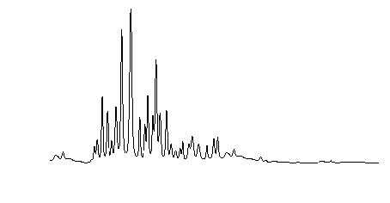

**(B)**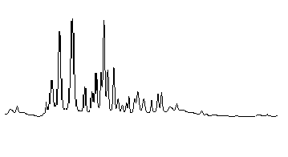

**(C)**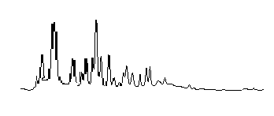

**(D)**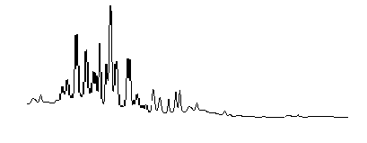

**(E)**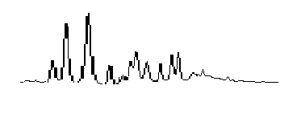



**2θ**

**Figure 3.4.2.1.1: X-RD graphs of (A)CBS, (B)CBS-β-CD, (C)CBS-β-CD-PVP K30, (D) CBS-β-CD-PEG 6000 and (E)CBS-β-CD-soluplus**

**(A)**

**(B)**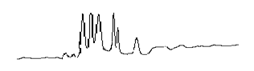

**(C)**

**(D)**

**(E)**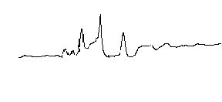



**2θ**

**Figure 3.4.2.1.2: X-RD graphs of (A)CBS, (B)CBS-HP-β-CD, (C)CBS-HP-β-CD-PVP K30, (D)CBS-HP-β-CD-PEG 6000and (E) CBS-β-CD-soluplus**

**Table 3.4.2.1: % RDC values from X-Ray diffractograms of CBS-binary and ternary systems**

|  |  |  |
| --- | --- | --- |
| **Product** | **2θ** | **% RDC\*** |
| Clopidogrel bisulphate | 3028 | - |
| CBS-β-CD | 914 | 30.19 |
| CBS-β-CD-PEG 6000 | 1050 | 34.69 |
| CBS-β-CD-PVP K30 | 1314 | 43.42 |
| CBS-β-CD-SOLUPLUS | 1519 | 50.19 |
| CBS-HP-β-CD | 964 | 31.84 |
| CBS-HP-β-CD-PEG 6000 | 1152 | 38.05 |
| CBS-HP-β-CD-PVP K30 | 1443 | 47.66 |
| CBS-HP-β-CD-SOLUPLUS | 1902 | 62.84 |

* % RDC= Relative Degree of Crystallinity

**X-RD studies of DTG**

The powdered X-Ray diffraction patterns of DTG in binary and ternary complexes are shown in **Figure 3.4.2.2.1** to **3.4.2.2.2** and their % RDC were calculated and are given in **Table 3.4.2.2**.

**(A)**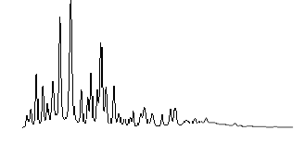

**(B)**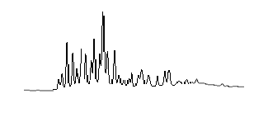

**(C)**

**(D)**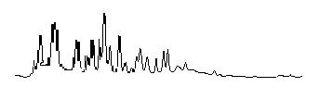

**(E)**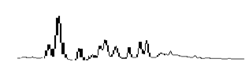



**2θ**

**Figure 3.4.2.2.1: X-RD graphs of (A) DTG, (B)DTG-β-CD, (C)DTG-β-CD-PVP K30, (D)DTG-β-CD-PEG 6000 and (E)DTG-β-CD-soluplus**

**(A)**

**(B)**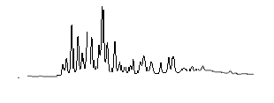

**(C)**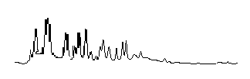

**(D)**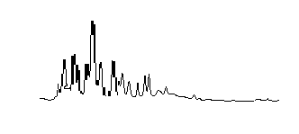

**(E)**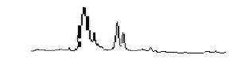



**2θ**

**Figure 3.4.2.2.2: X-RD graphs of (A)DTG, (B)DTG-HP-β-CD, (C)DTG-HP-β-CD-PVP K30,(D)DTG-HP-β-CD-PEG 6000 and (E)DTG-HP-β-CD-soluplus**

**Table 3.4.2.2: % RDC values from X-Ray diffractograms of DTG-binary and ternary systems**

|  |  |  |
| --- | --- | --- |
| **Product** | **2θ** | **% RDC\*** |
| Dolutegravir sodium | 6371 | - |
| DTG-β-CD | 1290 | 20.25 |
| DTG-β-CD-PEG 6000 | 1592 | 24.96 |
| DTG-β-CD-PVP K30 | 1661 | 26.08 |
| DTG-β-CD-SOLUPLUS | 1945 | 30.53 |
| DTG-HP-β-CD | 1364 | 21.41 |
| DTG-HP-β-CD-PEG 6000 | 1607 | 25.23 |
| DTG-HP-β-CD-PVP K30 | 1729 | 27.14 |
| DTG-HP-β-CD-SOLUPLUS | 2099 | 32.95 |

*% RDC= Relative Degree of Crystallinity

**SEM photographs of CBS**

The SEM photographs of CBS and its binary and ternary complexes are shown in **Figure 3.4.3.1.1** to **3.4.3.1.2.**

**(A)**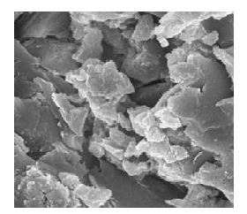

**(B)**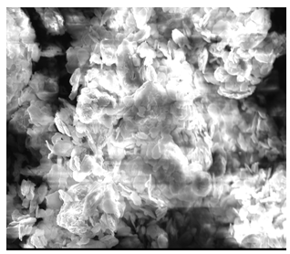

**(C)**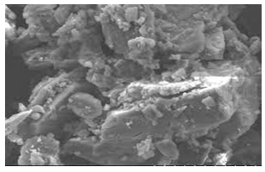

**(D)**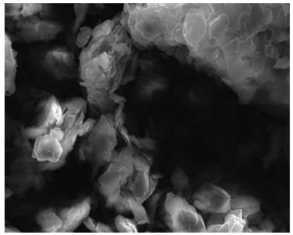

**(E)**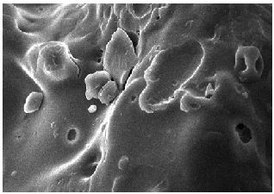

**Figure 3.4.3.1.1: SEM photographs of (A)CBS, (B)CBS-β-CD, (C)CBS-β-CD-PVP K30, (D)CBS-β-CD-PEG 6000 and(E)CBS-β-CD-soluplus**

**(A)**

**(B)**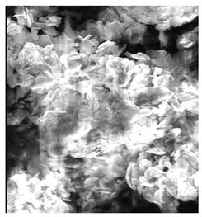

**(C)**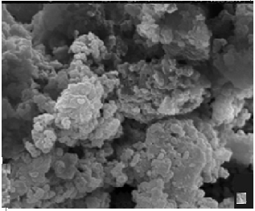

**(D)**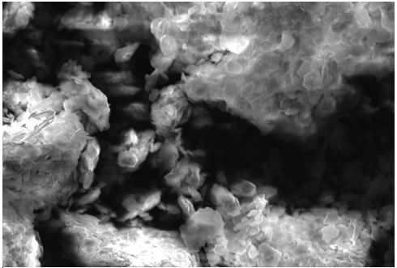

**(E)**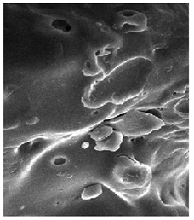

**Figure 3.4.3.1.2: SEM photographs of (A)CBS, (B)CBS-HP-β-CD, (C)CBS-HP-β-CD-PVP K30, (D)CBS-HP-β-CD-PEG 6000 and (E)CBS-β-CD-soluplus**

**SEM photographs of DTG**

The SEM photographs of DTG and its binary and ternary complexes are shown in **Figure 3.4.3.2.1** to **3.4.3.2.2.**

**(A)**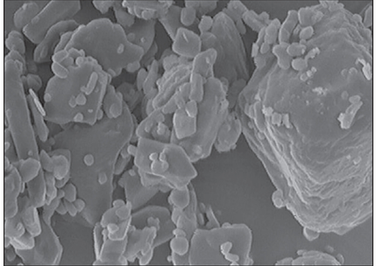

**(B)**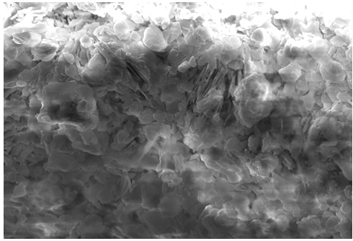

**(C)**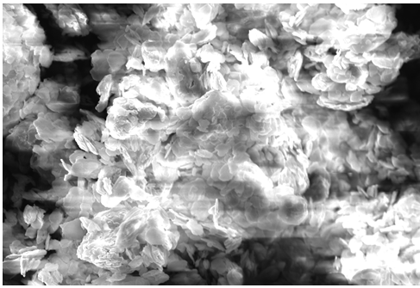

**(D)**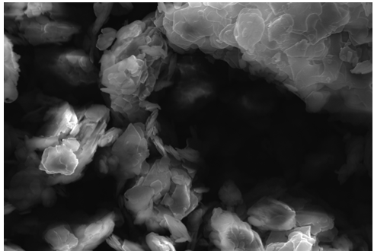

**(E)**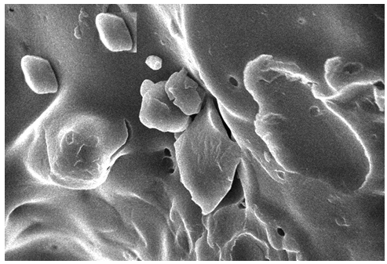

**Figure3.4.3.2.1: SEM photographs of (A)DTG, (B)DTG-β-CD, (C)DTG- β-CD-PVP K30, (D)DTG-β-CD-PEG 6000 and (E)DTG-β-CD-soluplus**

**(A)**

**(B)**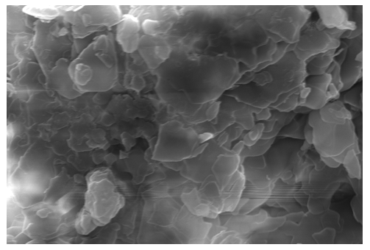

**(C)**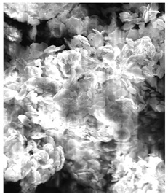

**(D)**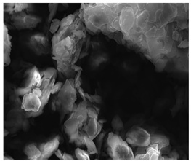

**(E)**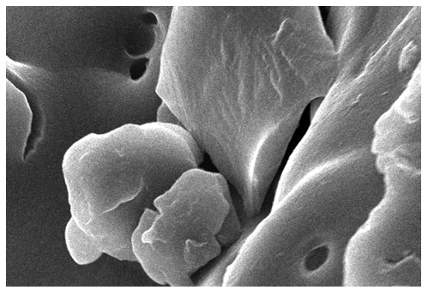

**Figure 3.4.3.2.2: SEM photographs of (A)DTG, (B)DTG-HP-β-CD, (C)DTG-HP-β-CD-PVP K30, (D)DTG-HP-β-CD-PEG 6000 and (E)DTG-HP-β-CD-soluplus**

**FTIR OF CBS and DTG**

The FTIR of CBS and DTG and its different binary systems with β-CD/ HP-β-CD and ternary systems with hydrophilic polymers such as PEG 6000, PVP K30 and soluplus are shown in the following sections:

* + FTIR spectral studies of CBS
  + FTIR spectral studies of DTG

**FTIR spectral studies of CBS**

The FTIR of CBS and its different binary systems with β-CD, HP-β-CD and ternary systems with hydrophilic polymers such as PVP K30, PEG 6000 and soluplus are shown in **Figure 3.4.4.1.1** to **Figure 3.4.4.1.9.**

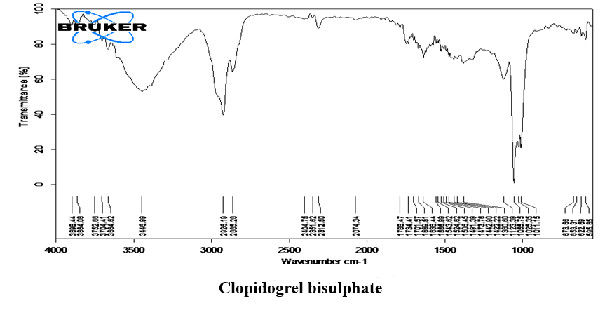**Figure 3.4.4.1.1:FTIR spectra of clopidogrel bisulphate**

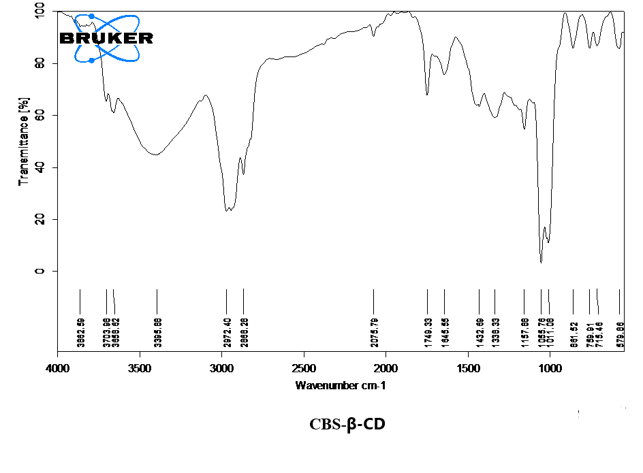**Figure 3.4.4.1.2: FTIR spectra of CBS-β-CD**

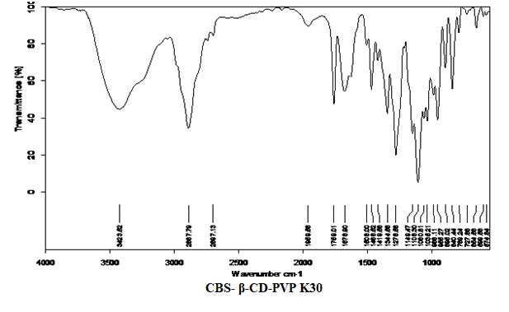**Figure 3.4.4.1.3: FTIR spectra of CBS- β-CD-PVP K30**

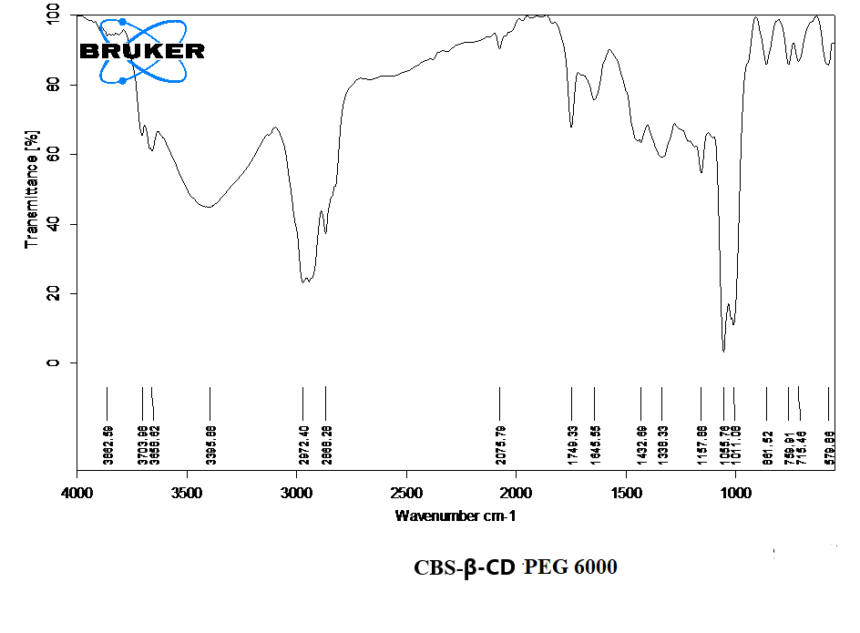**Figure 3.4.4.1.4: FTIR spectra of CBS-β-CD-PEG 6000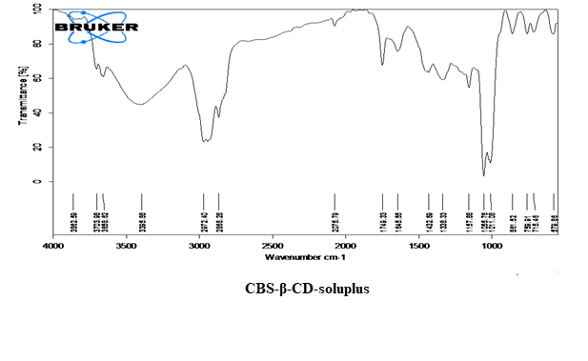Figure 3.4.4.1.5: FTIR spectra of CBS-β-CD-soluplus**

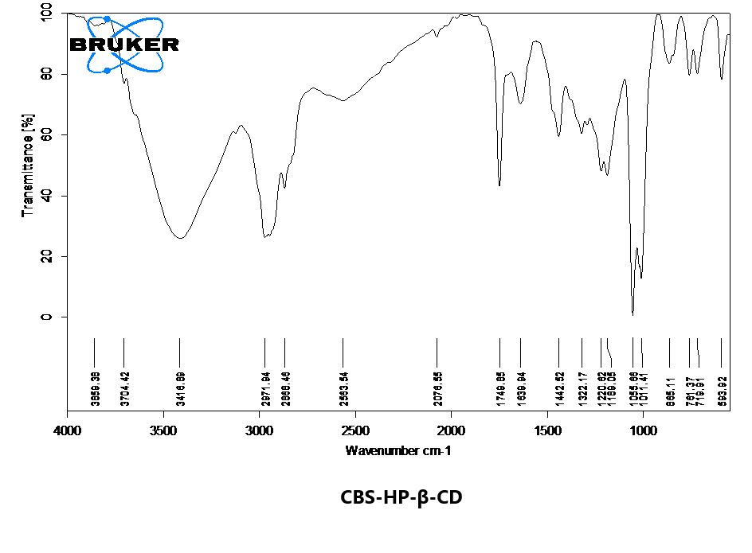**Figure 3.4.4.1.6: FTIR spectra of CBS-HP-β-CD**

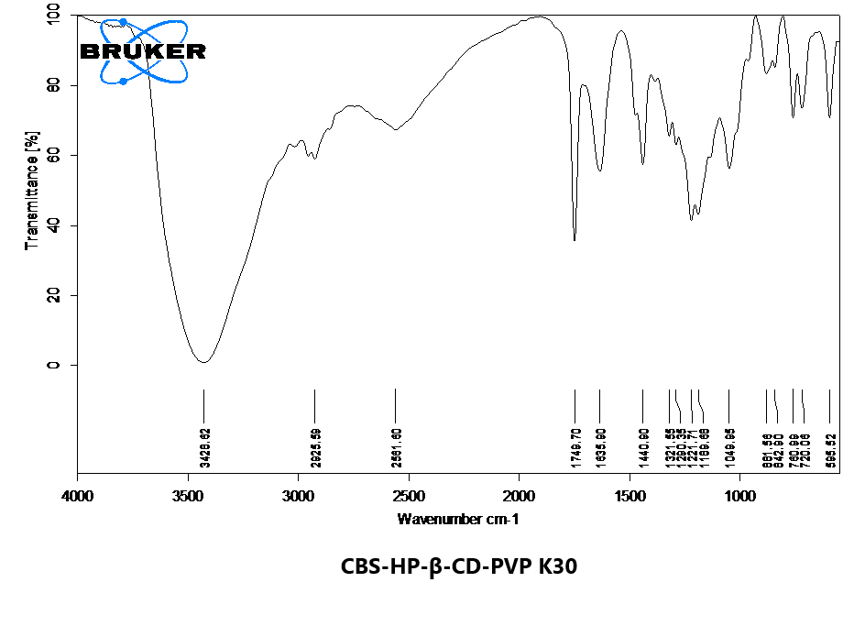**Figure 3.4.4.1.7: FTIR spectra of CBS-HP-β-CD-PVP K30**

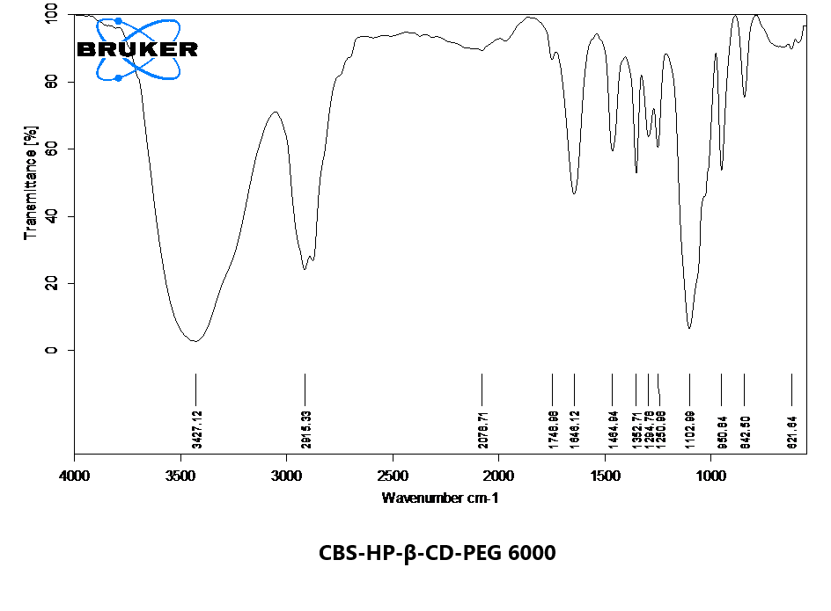**Figure 3.4.4.1.8: FTIR spectra of CBS-HP-β-CD-PEG 6000**

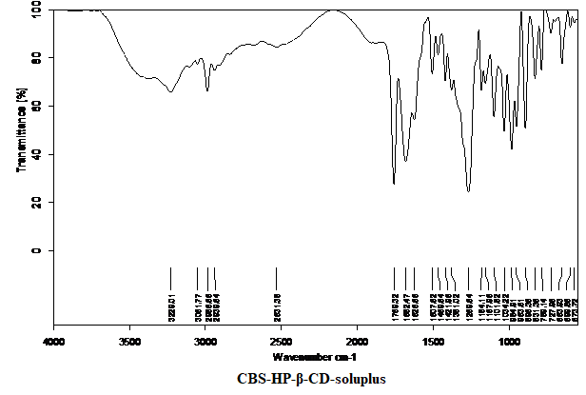**Figure 3.4.4.1.9: FTIR spectra of CBS-HP-β-CD-soluplus**

**FTIR spectral studies of DTG**

The FTIR of DTG and its different binary systems with β-CD, HP-β-CD and ternary systems with hydrophilic polymers such as PVP K30, PEG 6000 and soluplus are shown in **Figure 3.4.4.2.1 to Figure 3.4.4.2.9.**

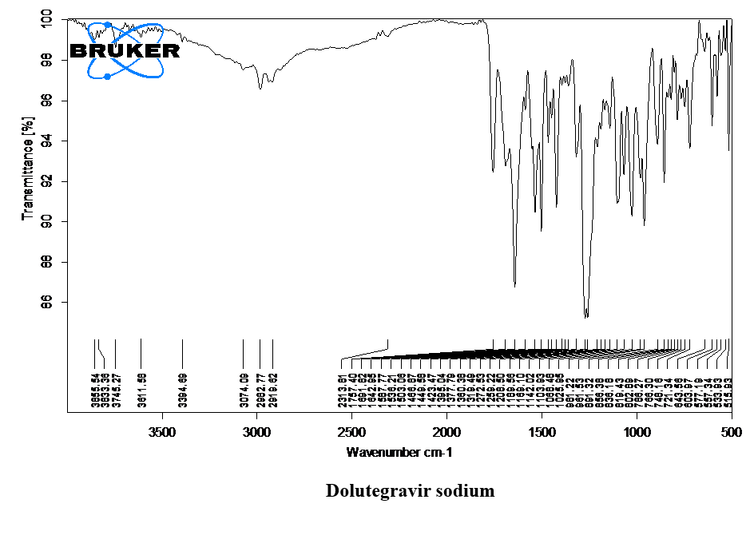**Figure 3.4.4.2.1: FTIR spectra of dolutegravir sodium**

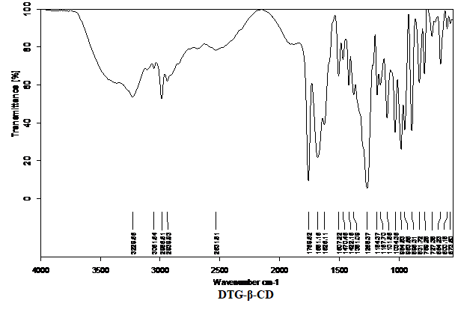**Figure 3.4.4.2.2: FTIR spectra of DTG-β-CD**

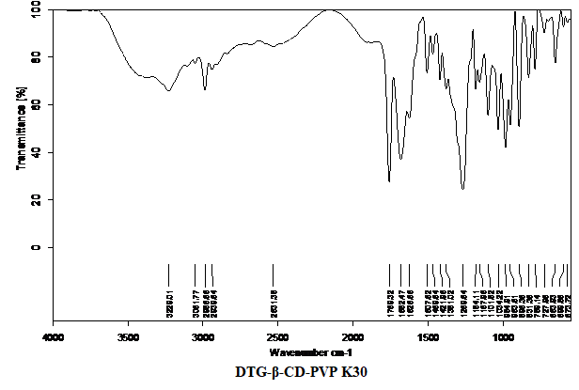**Figure 3.4.4.2.3: FTIR spectra of DTG-β-CD-PVP K30**

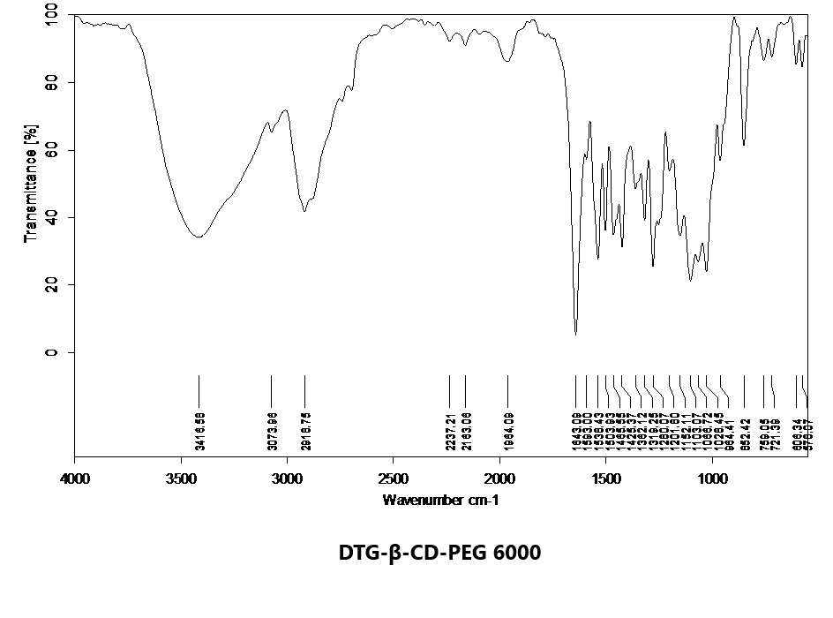**Figure 3.4.4.2.4: FTIR spectra of DTG-β-CD-PEG 6000**

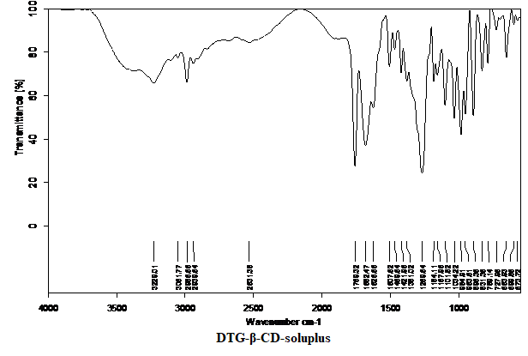**Figure 3.4.4.2.5: FTIR spectra of DTG-β-CD-soluplus**

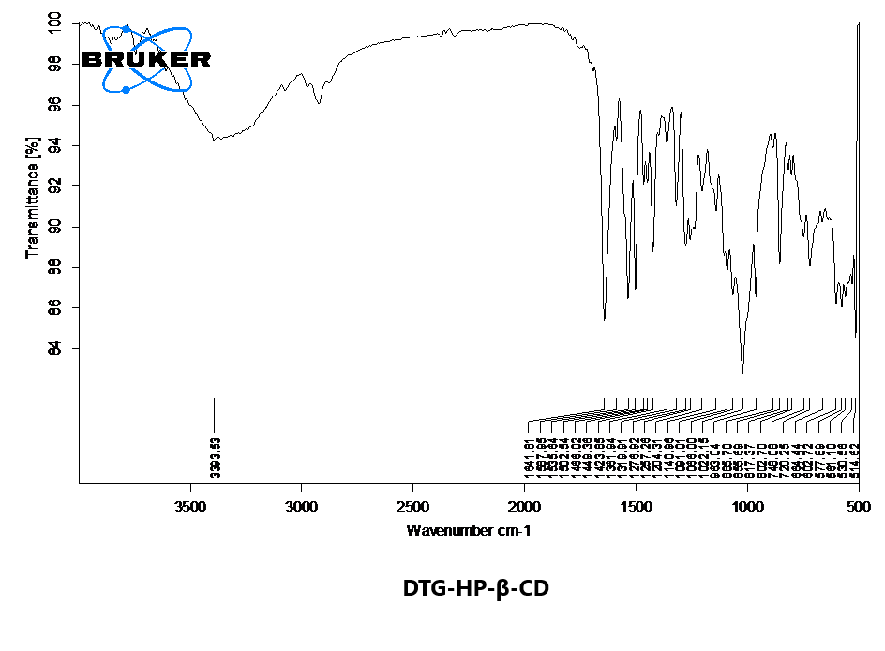**Figure 3.4.4.2.6: FTIR spectra of DTG-HP-β-CD**

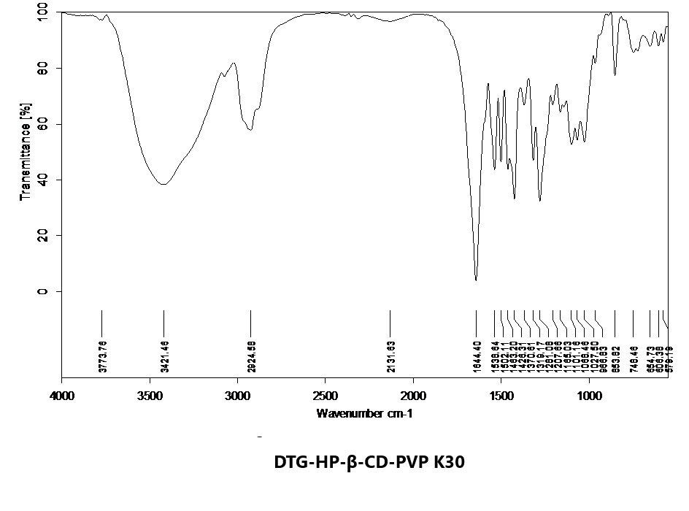**Figure 3.4.4.2.7: FTIR spectra of DTG-HP-β-CD-PVP K30**

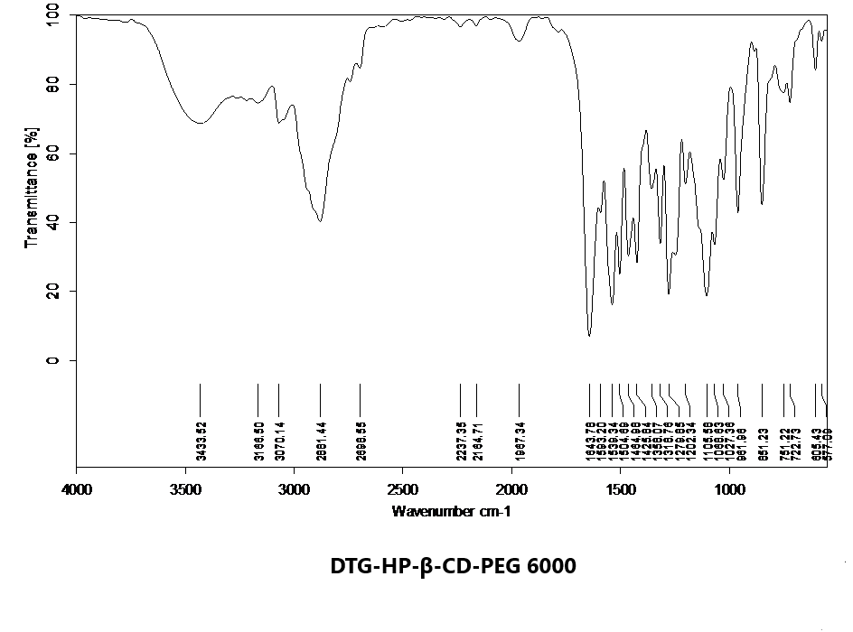**Figure 3.4.4.2.8: FTIR of spectra of DTG-HP-β-CD-PEG 6000**

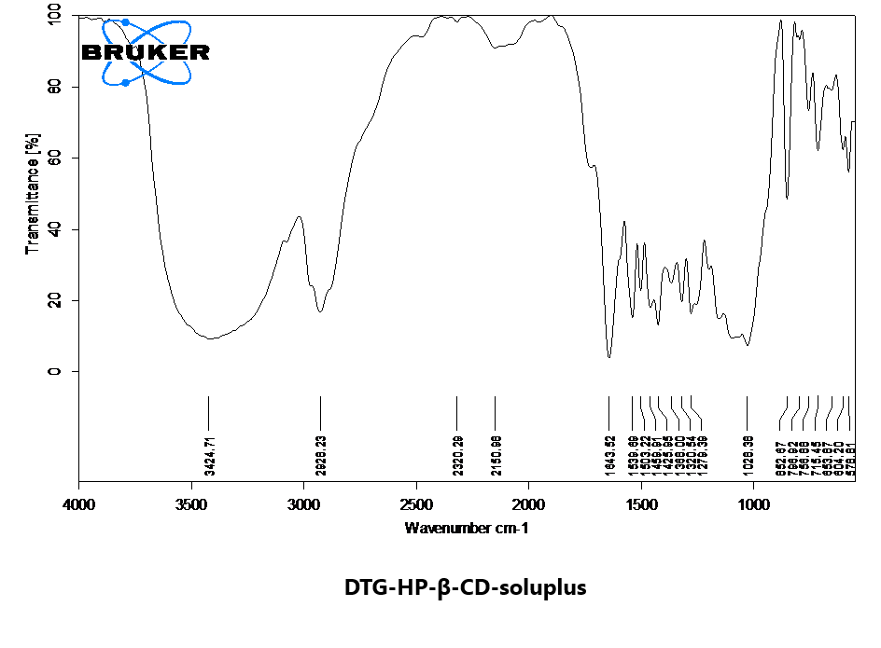**Figure 3.4.4.2.9: FTIR spectra of DTG-HP-β-CD-soluplus**

**DRUG CONTENT AND DISSOLUTION STUDIES**

A series 36 formulations of solid inclusion complexes were formed for each of the drugs C1 to C36 for CBS and F1 to F36 for DTG. These binary and ternary mixtures were then evaluated by studying their drug content uniformity, dissolution rate study and dissolution efficiency. The procedures adopted for these studies were described earlier in this chapter. The results obtained in these studies and their analysis is shown in the following tables.

**DRUG CONTENT UNIFORMITY**

The percentages of drug content present in the binary and ternary complexes of CBS and DTG was calculated and are mentioned in **Table 3.5.1.1** and **Table 3.5.1.2**.

**Table 3.5.1.1: Drug content of various CBS-β-CD and CBS-HP-β-CD complex systems**

|  |  |  |  |
| --- | --- | --- | --- |
| **Complex Systems** | **% CBS content\*** | **Complex Systems** | **% CBS content\*** |
| **With β-CD** | | **With HP-β-CD** | |
| C1 | 90.36±0.14 | C19 | 92.81±0.21 |
| C2 | 91.01±0.05 | C20 | 91.03±0.13 |
| C3 | 90.22±0.46 | C21 | 91.02±0.02 |
| C4 | 91.02±0.13 | C22 | 92.31±0.74 |
| C5 | 92.63±0.37 | C23 | 93.54±0.16 |
| C6 | 91.06±0.38 | C24 | 93.17±0.66 |
| C7 | 92.58±0.37 | C25 | 93.44±0.86 |
| C8 | 91.24±0.31 | C26 | 93.04±0.41 |
| C9 | 91.38±0.48 | C27 | 92.51±0.35 |
| C10 | 94.03±0.19 | C28 | 97.38±0.25 |
| C11 | 95.67±0.23 | C29 | 95.77±0.40 |
| C12 | 95.33±0.15 | C30 | 96.23±0.13 |
| C13 | 93.52±0.26 | C31 | 96.11±0.28 |
| C14 | 95.01±0.42 | C32 | 94.28±0.56 |
| C15 | 93.64±0.25 | C33 | 96.21±0.33 |
| C16 | 96.09±0.39 | C34 | 99.20±0.02 |
| C17 | 97.57±0.22 | C35 | 99.43±0.10 |
| C18 | 96.19±0.38 | C36 | 99.68±0.28 |

* mean ±S.D, n=3

**Table 3.5.1.2: Drug content of various DTG-β-CD and DTG-HP-β-CD complex systems**

|  |  |  |  |
| --- | --- | --- | --- |
| **Complex Systems** | **% DTG content\*** | **Complex Systems** | **% DTG content\*** |
| **With β-CD** | | **With HP-β-CD** | |
| F1 | 91.37±0.48 | F10 | 92.06±0.35 |
| F2 | 92.28±0.21 | F11 | 92.48±0.18 |
| F3 | 91.19±0.09 | F12 | 93.97±0.93 |
| F4 | 92.17±0.78 | F13 | 94.81±0.21 |
| F5 | 93.94±0.32 | F14 | 94.13±0.78 |
| F6 | 92.36±0.56 | F15 | 95.26±0.47 |
| F7 | 93.75±0.62 | F16 | 94.37±0.25 |
| F8 | 91.82±0.81 | F17 | 95.18±0.11 |
| F9 | 92.66±0.37 | F18 | 94.02±0.69 |
| F19 | 95.41±0.54 | F28 | 97.49±0.98 |
| F20 | 96.28±0.88 | F29 | 97.56±0.64 |
| F21 | 97.35±0.01 | F30 | 98.74±0.17 |
| F22 | 94.39±0.33 | F31 | 96.29±0.47 |
| F23 | 95.07±0.19 | F32 | 96.48±0.20 |
| F24 | 95.63±0.15 | F33 | 97.15±0.51 |
| F25 | 97.12±0.31 | F34 | 99.71±0.19 |
| F26 | 97.56±0.29 | F35 | 99.87±0.05 |
| F27 | 98.38±0.11 | F36 | 99.03±0.12 |

* mean ±S.D, n=3

**DISSOLUTION CHARACTERISTICS**

The dissolution rate of CBS and DTG drugs from various cyclodextrin solid inclusion complexes was studied and compared with that of pure drug in each case and the dissolution characteristics of CBS and DTG are discussed in the following sections **3.5.2.1** and **3.5.2.2**.

* *In vitro* dissolution studies of clopidogrel bisulphate
* *In vitro* dissolution studies of dolutegravir sodium

***INVITRO* DISSOLUTION STUDIES OF CBS**

The dissolution data of CBS-CD complexes are given in **Table 3.5.2.1.1.1** to **3.5.2.1.1.2** and the dissolution profiles are shown in **Figure 3.5.2.1.1.1** to **3.5.2.1.1.4**

**Dissolution data of CBS with β-CD**

The dissolution profiles of pure drug CBS and inclusion complexes with β-CD prepared by the physical mixing, kneading and solvent evaporation methods in 0.1 N HCl and pH 6.8 phosphate buffer media are given in **Table 3.5.2.1.1.1** and shown in **Figure 3.5.2.1.1.1** and **3.5.2.1.1.2**. Dissolution profiles of ternary complexes prepared by the optimized kneading method with the addition of hydrophilic polymers in pH 6.8 phosphate buffer are given in **Table 3.5.2.1.1.2** and shown in **Figure 3.5.2.1.1.3 and 3.5.2.1.1.4.**

**Dissolution profiles of CBS and CBS-β-CD complexes prepared by the physical mixing, kneading and solvent evaporation methods**

|  |  |  |  |  |  |  |  |  |  |  |
| --- | --- | --- | --- | --- | --- | --- | --- | --- | --- | --- |
| **TIME**  **(min)** |  | **CUMULATIVE % DRUG RELEASE OF CBS** | | | | | | | | |
| **C** | **C1** | **C2** | **C3** | **C4** | **C5** | **C6** | **C7** | **C8** | **C9** |
| 10 | 4.62±0.15 | 6.90±0.03 | 7.52±0.25 | 8.03±0.04 | 9.15±0.46 | 9.72±0.15 | 10.26±0.51 | 8.52±1.0 | 8.34±0.37 | 9.46±0.75 |
| 20 | 6.45±0.19 | 11.27±0.22 | 13.54±0.07 | 14.46±0.80 | 15.04±0.44 | 16.61±0.26 | 14.36±0.61 | 16.42±0.17 | 17.49±0.14 | 15.14±0.78 |
| 30 | 8.39±0.04 | 19.46±0.79 | 21.35±0.12 | 22.58±0.58 | 26.83±1.11 | 27.86±0.16 | 25.79±0.65 | 26.53±0.12 | 27.66±0.18 | 25.76±0.89 |
| 40 | 11.71±0.05 | 23.77±0.70 | 25.71±0.08 | 24.52±0.33 | 31.37±0.11 | 32.40±0.01 | 30.61±0.19 | 33.90±0.68 | 34.15±0.35 | 35.30±0.83 |
| 50 | 15.27±0.06 | 36.86±0.05 | 37.92±0.42 | 36.78±0.62 | 42.53±0.06 | 46.53±0.82 | 44.17±0.76 | 45.18±0.60 | 42.84±0.25 | 41.42±0.97 |
| 60 | 18.16±0.46 | 42.82±0.05 | 43.89±0.36 | 46.19±0.11 | 55.43±0.85 | 55.97±0.74 | 56.34±0.42 | 49.31±0.65 | 55.97±0.86 | 54.29±0.09 |
| 80 | 22.49±0.18 | 67.44±0.16 | 69.03±0.34 | 59.30±0.56 | 71.40±0.45 | 75.54±0.66 | 74.12±0.12 | 70.55±0.38 | 80.54±0.53 | 75.43±0.72 |
| 100 | 30.33±0.46 | 89.35±0.81 | 88.18±0.41 | 86.93±0.75 | 81.13±0.52 | 85.49±0.24 | 82.21±0.14 | 81.01±0.59 | 90.17±0.92 | 86.22±0.23 |
| 110 | 34.21±0.56 | 90.62±0.99 | 93.27±0.28 | 95.19±0.14 | 97.04±0.95 | 100.01±0.47 | 98.77±0.43 | 95.62±0.04 | 99.09±0.30 | 100.99±0.22 |
| 120 | 38.55±0.91 | 99.35±0.52 | 98.09±0.17 | 100.24±0.08 | - | - | - | 100.01±0.26 | - | - |

* mean ±S.D, n=3

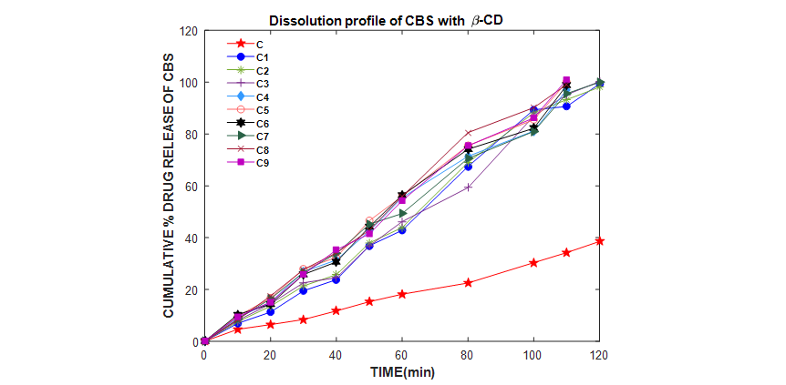

**Table 3.5.2.1.1.1: Dissolution profiles of CBS and CBS-β-CD complexes prepared by the physical mixing, kneading and solvent evaporation methods**

|  |  |  |  |  |  |  |  |  |  |  |
| --- | --- | --- | --- | --- | --- | --- | --- | --- | --- | --- |
| **TIME**  **(min)** | **CUMULATIVE % DRUG RELEASE OF CBS\*** | | | | | | | | | |
| **C** | **C1** | **C2** | **C3** | **C4** | **C5** | **C6** | **C7** | **C8** | **C9** |
| 10 | 6.24± 0.49 | 14.11±0.53 | 15.07±0.98 | 12.32±0.01 | 20.19±0.94 | 23.76±0.21 | 20.82±0.02 | 22.85±0.80 | 22.99±0.12 | 21.44±0.28 |
| 20 | 8.69±0.11 | 22.57±0.33 | 23.28±0.04 | 22.45±0.10 | 28.68±0.99 | 30.57±0.22 | 31.25±0.29 | 32.18±0.16 | 31.34±0.12 | 30.75±0.24 |
| 30 | 13.00±0.47 | 31.32±0.01 | 32.04±0.91 | 31.79±0.98 | 39.89±0.73 | 40.30±0.20 | 41.83±0.67 | 40.48±0.18 | 40.88±0.92 | 41.99±0.66 |
| 40 | 16.67±0.24 | 45.32±0.38 | 40.43±0.89 | 44.72±0.73 | 48.07±0.06 | 56.25±0.23 | 55.62±0.18 | 56.38±0.66 | 53.93±0.48 | 53.74±0.83 |
| 50 | 21.19±0.14 | 56.76±0.96 | 54.31±0.49 | 52.37±0.04 | 61.35±0.76 | 65.56±0.10 | 62.36±0.41 | 64.58±0.66 | 61.29±0.27 | 61.27±0.22 |
| 60 | 26.91±0.84 | 77.40±0.23 | 78.21±0.69 | 79.92±0.12 | 82.13±0.44 | 85.45±0.45 | 83.56±0.24 | 83.89±0.25 | 82.92±0.68 | 81.23±0.74 |
| 65 | 29.12±0.77 | 83.12±0.19 | 86.33±0.33 | 82.42±0.18 | 91.46±0.88 | 90.39±0.36 | 89.51±0.81 | 85.29±0.73 | 91.67±0.37 | 89.96±0.63 |
| 70 | 34.73±0.34 | 89.56± 0.54 | 90.12±0.90 | 88.75±0.02 | 95.38±0.85 | 94.56±0.53 | 92.07±0.77 | 90.74±0.78 | 96.13±0.71 | 93.40±0.58 |
| 75 | 36.41±0.53 | 94.05±0.25 | 96.44±0.52 | 97.35±0.92 | 99.49±0.29 | 100.56±0.88 | 100.33±0.84 | 95.02±0.83 | 99.05±0.65 | 96.77±0.59 |
| 80 | 39.35±0.62 | 100.73±0.23 | 99.23±0.76 | 100.14±0.03 | - | - | - | 100.09±0.57 | - | 99.99±0.34 |

* mean ±S.D, n=3

**C:\Users\user\Desktop\prasanti Plots\23 Dec 2019 Plots\Dissolution Plots\C1-C9\Fig C to C9.emf**

**Figure 3.5.2.1.1.1: Dissolution profiles of CBS and CBS-β-CD complexes prepared by the physical mixing, kneading and solvent evaporation methods**

**C:\Users\user\Desktop\prasanti Plots\23 Dec 2019 Plots\First Order Plots\C1C9\C1C9.emf**

**Figure 3.5.2.1.1.2: First order dissolution plots of CBS and CBS-β-CD complexes prepared by the physical mixing, kneading and solvent evaporation methods**

**Table 3.5.2.1.1.2: Dissolution profiles of CBS, CBS-β-CD-PVP K30, CBS-β-CD-PEG 6000 and CBS-β-CD-soluplus complex systems prepared by the optimized kneading method**

|  |  |  |  |  |  |  |  |  |  |  |
| --- | --- | --- | --- | --- | --- | --- | --- | --- | --- | --- |
|  | **CUMULATIVE % DRUG RELEASE OF CBS\*** | | | | | | | | | |
| **TIME**  **(min)** | **C** | **C10** | **C11** | **C12** | **C13** | **C14** | **C15** | **C16** | **C17** | **C18** |
| 10 | 6.24± 0.49 | 31.00±0.68 | 31.46±0.45 | 32.86±0.13 | 25.89±0.80 | 27.97±0.39 | 26.45±0.50 | 31.26±0.61 | 33.44±0.76 | 31.77±0.23 |
| 20 | 8.69±0.11 | 41.16±0.81 | 43.72±0.38 | 45.81±0.54 | 34.13±0.12 | 39.24±0.80 | 38.91±0.26 | 43.99±0.94 | 42.83±0.77 | 45.63±0.17 |
| 30 | 13.00±0.47 | 56.49±0.45 | 57.24±0.14 | 55.54±0.08 | 50.64±0.78 | 48.42±0.18 | 47.84±0.25 | 62.08±0.94 | 64.24±0.27 | 64.76±0.48 |
| 40 | 16.67±0.24 | 65.10±0.58 | 63.88±0.75 | 64.16±0.36 | 66.24±0.13 | 65.76±0.98 | 64.93±0.27 | 73.82±0.64 | 78.30±0.29 | 79.02±0.09 |
| 50 | 21.19±0.14 | 79.96±0.52 | 75.99±0.62 | 75.50±0.16 | 71.79±0.93 | 74.59±0.79 | 78.49±0.10 | 87.47±0.07 | 89.30±0.49 | 84.83±0.75 |
| 60 | 26.91±0.84 | 92.48±0.33 | 94.68±0.18 | 93.64±0.46 | 89.84±0.69 | 92.60±0.38 | 89.76±0.18 | 94.74±0.11 | 95.68±0.51 | 94.99±0.82 |
| 65 | 29.12±0.77 | 100.74±0.20 | 99.31±0.82 | 100.59±0.18 | 94.15±0.98 | 96.89±0.31 | 94.11±0.25 | 100.03±0.41 | 100.95±0.55 | 100.34±0.64 |
| 70 | 34.73±0.34 | - | - | - | 100.70±0.31 | 100.09±0.16 | 99.01±0.21 | - | - | - |

* mean ±S.D, n=3

**C:\Users\user\Desktop\prasanti Plots\23 Dec 2019 Plots\Dissolution Plots\C10-C18\C10C18.emf**

**Figure 3.5.2.1.1.3: Dissolution profiles of CBS, CBS-β-CD-PVP K30, CBS-β-CD-PEG 6000 and CBS-β-CD-soluplus complex systems prepared by the optimized kneading method**

**C:\Users\user\Desktop\prasanti Plots\23 Dec 2019 Plots\First Order Plots\C10C18\C10C18.emf**

**Figure 3.5.2.1.1.4: First orderdissolution plots of CBS, CBS-β-CD-PVP K30, CBS-β-CD-PEG 6000 and CBS-β-CD-soluplus complex systems prepared by the optimized kneading method**

**Dissolution data of CBS with HP-β-CD**

The dissolution profiles of pure drug CBS and inclusion complexes with HP-β-CD prepared by the physical mixing, kneading and solvent evaporation methods in 0.1 N HCl and pH 6.8 phosphate buffer media are given in **Table 3.5.2.1.2.1** and shown in **Figure 3.5.2.1.2.1** and **3.5.2.1.2.2**. Dissolution profiles of ternary complexes prepared by the optimized kneading method with the addition of hydrophilic polymers in pH 6.8 phosphate buffer media are given in **Table 3.5.2.1.2.2** and shown in **Figure 3.5.2.1.2.3** and **3.5.2.1.2.4.**

**Dissolution profiles of CBS and CBS-HP-β-CD complexes prepared by the physical mixing, kneading and solvent evaporation methods**

|  |  |  |  |  |  |  |  |  |  |  |
| --- | --- | --- | --- | --- | --- | --- | --- | --- | --- | --- |
| **TIME**  **(min)** |  | **CUMULATIVE % DRUG RELEASE OF CBS\*** | | | | | | | | |
| **C** | **C19** | **C20** | **C21** | **C22** | **C23** | **C24** | **C25** | **C26** | **C27** |
| 10 | 4.62±0.15 | 9.37±0.75 | 10.22±0.42 | 11.72±0.15 | 12.29±0.04 | 12.40±0.58 | 13.19±0.13 | 11.54±0.05 | 11.33±0.09 | 12.49±0.55 |
| 20 | 6.45±0.19 | 15.46±0.62 | 17.82±0.02 | 18.31±0.62 | 19.02±0.05 | 20.61±0.62 | 18.31±0.24 | 20.15±0.60 | 21.67±0.75 | 19.92±0.29 |
| 30 | 8.39±0.04 | 24.88±0.27 | 25.13±0.31 | 27.45±0.24 | 30.50±0.14 | 31.87±0.03 | 30.39±0.65 | 31.27±0.01 | 32.27±0.36 | 30.24±0.15 |
| 40 | 11.71±0.05 | 27.25±0.37 | 29.82±0.33 | 28.67±0.25 | 35.26±0.79 | 36.70±0.49 | 34.61±0.18 | 37.26±0.22 | 38.16±0.05 | 39.54±0.01 |
| 50 | 15.27±0.06 | 40.77±0.46 | 41.74±0.07 | 40.93±0.17 | 46.52±0.52 | 50.25±0.41 | 48.69±0.93 | 46.19±0.31 | 47.10±0.94 | 45.49±0.87 |
| 60 | 18.16±0.46 | 46.51±0.39 | 49.72±0.53 | 52.60±0.98 | 59.14±0.82 | 58.43±0.97 | 59.42±0.64 | 57.15±0.96 | 56.12±0.58 | 57.13±0.99 |
| 80 | 22.49±0.18 | 67.04±0.14 | 70.13±0.29 | 72.21±0.12 | 69.58±0.48 | 71.53±0.16 | 80.14±0.40 | 78.61±0.83 | 78.59±0.53 | 80.73±0.87 |
| 90 | 26.540.93 | 86.34±0.15 | 87.85±0.80 | 86.64±0.02 | 80.24±0.12 | 90.25±0.70 | 100.87±0.18 | 89.94±0.72 | 98.55±0.91 | 92.98±0.43 |
| 100 | 30.330.46 | 99.31±0.48 | 98.67±0.56 | 99.26±0.61 | 99.14±0.40 | 100.08±0.85 | - | 98.45±0.95 | - | 100.66±1.2 |

* mean ±S.D, n=3

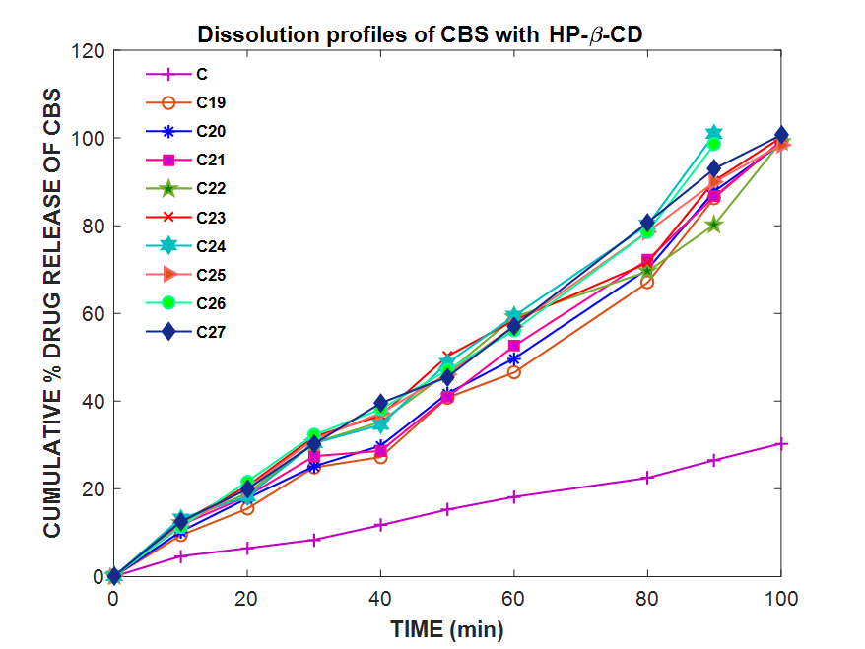

**Table 3.5.2.1.2.1: Dissolution profiles of CBS and CBS-HP-β-CD complexes prepared by the physical mixing, kneading and solvent evaporation methods**

|  |  |  |  |  |  |  |  |  |  |  |
| --- | --- | --- | --- | --- | --- | --- | --- | --- | --- | --- |
| **TIME**  **(min)** | **CUMULATIVE % DRUG RELEASE OF CBS\*** | | | | | | | | | |
| **C** | **C19** | **C20** | **C21** | **C22** | **C23** | **C24** | **C25** | **C26** | **C27** |
| 10 | 6.24± 0.49 | 17.54±0.34 | 18.33±0.39 | 16.62±0.28 | 25.72±0.44 | 26.35±0.72 | 25.18±0.29 | 26.82±0.17 | 23.67±0.96 | 24.25±0.14 |
| 20 | 8.69±0.11 | 25.91±0.23 | 23.79±0.61 | 27.26±0.85 | 38.99±0.34 | 39.21±0.19 | 39.04±0.28 | 40.16±0.46 | 33.08±0.17 | 34.37±0.94 |
| 30 | 13.00±0.47 | 39.46±0.85 | 36.93±0.27 | 36.64±0.94 | 45.58±0.94 | 49.40±0.78 | 48.39±0.26 | 51.46±0.77 | 50.13±0.33 | 49.46±0.44 |
| 40 | 16.67±0.24 | 56.02±0.58 | 55.93±0.66 | 54.60±0.19 | 65.41±0.12 | 62.44±0.26 | 69.41±0.14 | 65.90±0.40 | 66.06±0.99 | 64.19±0.67 |
| 50 | 21.19±0.14 | 68.35±0.99 | 67.59±0.16 | 68.81±0.84 | 74.23±0.94 | 75.25±0.78 | 76.24±0.19 | 71.03±0.04 | 70.23±0.53 | 72.76±0.26 |
| 60 | 26.91±0.84 | 84.43±0.09 | 82.94±0.12 | 82.76±0.70 | 92.54±0.63 | 91.13±0.13 | 91.23±0.39 | 92.04±0.05 | 90.63±0.07 | 90.01±0.15 |
| 65 | 29.12±0.77 | 90.18±0.54 | 93.65±0.46 | 92.49±0.51 | 95.51±0.02 | 96.27±0.11 | 94.57±0.17 | 94.68±0.61 | 94.11±0.12 | 96.96±0.34 |
| 70 | 34.73±0.34 | 97.43±0.56 | 95.11±0.21 | 99.71±0.39 | 100.25±0.25 | 99.22±0.23 | 98.67±0.20 | 97.19±0.91 | 96.33±0.60 | 99.01±0.43 |
| 75 | 36.41±0.53 | 101.63±0.50 | 100.32±0.62 | - | - | - | - | 100.25±0.31 | 100.59±0.01 | - |

* mean ±S.D, n=3

**C:\Users\user\Desktop\prasanti Plots\23 Dec 2019 Plots\Dissolution Plots\C19-C27\C19C27.emf**

**Figure 3.5.2.1.2.1: Dissolution profiles of CBS and CBS-HP-β-CD complexes prepared by the physical mixing, kneading and solvent evaporation methods**

**C:\Users\user\Desktop\prasanti Plots\23 Dec 2019 Plots\First Order Plots\C19C27\C19C27.emf**

**Figure 3.5.2.1.2.2: First order dissolution plots of CBS and CBS-HP-β-CD complexes prepared by the physical mixing, kneading and solvent evaporation methods**

**Table 3.5.2.1.2.2: Dissolution profiles of CBS, CBS-HP-β-CD-PVP K30, CBS-HP-β-CD-PEG 6000 and CBS-HP-β-CD- soluplus complex systems prepared by the optimized kneading method**

|  |  |  |  |  |  |  |  |  |  |  |
| --- | --- | --- | --- | --- | --- | --- | --- | --- | --- | --- |
| **TIME**  **(min)** | **% CUMULATIVE DRUG RELEASE OF CBS\*** | | | | | | | | | |
| **C** | **C28** | **C29** | **C30** | **C31** | **C32** | **C33** | **C34** | **C35** | **C36** |
| 10 | 6.24± 0.49 | 44.45±0.14 | 44.10±0.07 | 42.86±0.23 | 41.66±0.52 | 37.05±0.19 | 38.66±0.02 | 59.84±0.22 | 48.57±0.37 | 47.01±0.24 |
| 20 | 8.69±0.11 | 56.84±0.57 | 59.61±0.15 | 60.96±0.28 | 55.38±0.37 | 47.55±0.28 | 46.09±0.82 | 73.55±0.31 | 64.01±0.29 | 62.08±0.75 |
| 30 | 13.00±0.47 | 67.80±0.22 | 70.23±0.04 | 72.27±0.32 | 66.83±0.76 | 65.98±0.39 | 68.91±0.30 | 88.49±0.41 | 70.98±0.56 | 74.33±0.99 |
| 40 | 16.67±0.24 | 73.62±0.31 | 82.68±0.56 | 77.07±0.40 | 78.93±0.92 | 74.88±0.89 | 72.34±0.65 | 91.07±0.55 | 82.43±0.40 | 85.72±0.61 |
| 50 | 21.19±0.14 | 82.84±0.32 | 90.65±0.76 | 87.76±0.54 | 83.47±0.21 | 80.93±0.48 | 81.16±0.56 | 95.41±0.62 | 90.93±0.34 | 88.34±0.13 |
| 60 | 26.91±0.84 | 97.54±0.45 | 96.33±0.39 | 96.01±0.31 | 96.14±0.79 | 95.89±0.07 | 95.64±0.85 | 100.12±0.83 | 99.05±0.22 | 97.85±0.61 |
| 65 | 29.12±0.77 | 100.22±0.54 | 100.37±0.58 | 99.80±0.96 | 99.99±0.10 | 100.64±0.87 | 100.15±0.21 | - | - | 100.01±0.66 |

* mean ±S.D, n=3

**C:\Users\user\Desktop\prasanti Plots\23 Dec 2019 Plots\Dissolution Plots\C28-C36\C28C36.emf**

**Figure 3.5.2.1.2.3: Dissolution profiles of CBS, CBS-HP-β-CD-PVP K30, CBS-HP-β-CD-PEG 6000 and CBS-HP-β-CD- soluplus complex systems prepared by the optimized kneading method**

**C:\Users\user\Desktop\prasanti Plots\23 Dec 2019 Plots\First Order Plots\C28C36\C28C36.emf**

**Figure 3.5.2.1.2.4: First order dissolution plots of CBS, CBS-HP-β-CD-PVP K30, CBS-HP-β-CD-PEG 6000 and CBS-HP-β-CD-soluplus complex systems prepared by the optimized kneading method**

***INVITRO* DISSOLUTION STUDIES OF DTG**

The dissolution data of DTG-CD complexes are given in **Table 3.5.2.2.1.1** to **3.5.2.2.2.2** and the dissolution profiles are shown in **Figure 3.5.2.2.1.1** to **3.5.2.2.2.6**

**Dissolution data of DTG with β-CD**

The dissolution profiles of pure drug DTG and inclusion complexes with β-CD prepared by the physical mixing, kneading and solvent evaporation methods in 0.1 N HCl and pH 6.8 phosphate buffer are given in **Table 3.5.2.2.1.1** and shown in **Figure 3.5.2.2.1.1** and **3.5.2.2.1.2**. Dissolution profiles of ternary complexes prepared by the optimized kneading method with the addition of hydrophilic polymers pH 6.8 phosphate buffer are given in **Table3.5.2.2.1.2** and shown in **Figure 3.5.2.2.1.3** and **3.5.2.2.1.4**.

**Dissolution profiles of DTG and DTG-β-CD complexes prepared by the physical mixing, kneading and solvent evaporation methods**

|  |  |  |  |  |  |  |  |  |  |  |
| --- | --- | --- | --- | --- | --- | --- | --- | --- | --- | --- |
| **TIME**  **(min)** |  | **CUMULATIVE % DRUG RELEASE OF DTG\*** | | | | | | | | |
| **F** | **F1** | **F2** | **F3** | **F4** | **F5** | **F6** | **F7** | **F8** | **F9** |
| 10 | 5.12±0.17 | 9.87±0.15 | 10.37±0.62 | 9.98±0.91 | 10.94±0.25 | 13.84±0.14 | 12.67±0.21 | 12.06±0.03 | 12.36±0.06 | 11.77±0.81 |
| 20 | 7.23±0.29 | 13.99±0.35 | 15.58±0.37 | 13.35±0.53 | 16.73±0.75 | 19.57±0.32 | 18.45±0.98 | 17.31±0.47 | 18.97±0.53 | 17.83±0.25 |
| 30 | 11.04±0.58 | 22.19±0.62 | 23.02±0.60 | 21.46±0.22 | 24.19±0.18 | 26.38±0.76 | 25.85±0.05 | 24.74±0.99 | 23.23±0.02 | 23.57±0.68 |
| 40 | 12.51±0.04 | 30.78±0.82 | 29.57±0.93 | 28.84±0.13 | 32.14±0.23 | 34.35±0.25 | 33.01±0.15 | 31.96±0.37 | 33.88±0.18 | 31.69±0.28 |
| 50 | 17.38±0.55 | 33.08±0.64 | 32.26±0.97 | 31.96±0.06 | 43.41±0.56 | 46.73±0.28 | 45.56±0.73 | 41.45±0.16 | 46.07±0.35 | 43.12±0.44 |
| 60 | 21.82±0.27 | 42.95±0.24 | 43.20±0.45 | 44.45±0.12 | 50.47±0.03 | 52.82±0.05 | 53.61±0.27 | 46.91±0.17 | 50.33±0.81 | 49.84±0.29 |
| 80 | 25.73±0.07 | 65.25±0.97 | 70.12±0.51 | 68.05±0.36 | 75.35±0.63 | 69.02±0.08 | 82.67±0.70 | 77.52±0.52 | 61.11±0.08 | 68.03±0.13 |
| 100 | 32.62±0.59 | 82.13±0.12 | 86.38±0.25 | 89.96±0.15 | 98.66±0.10 | 88.22±0.90 | 100.53±0.21 | 85.01±0.16 | 80.86±0.13 | 86.65±0.76 |
| 120 | 37.28±0.67 | 100.01±0.17 | 99.56±0.21 | 98.05±0.37 | - | 99.97±0.04 | - | 99.08±0.74 | 98.65±0.64 | 100.23±1.08 |

* mean ±S.D, n=3

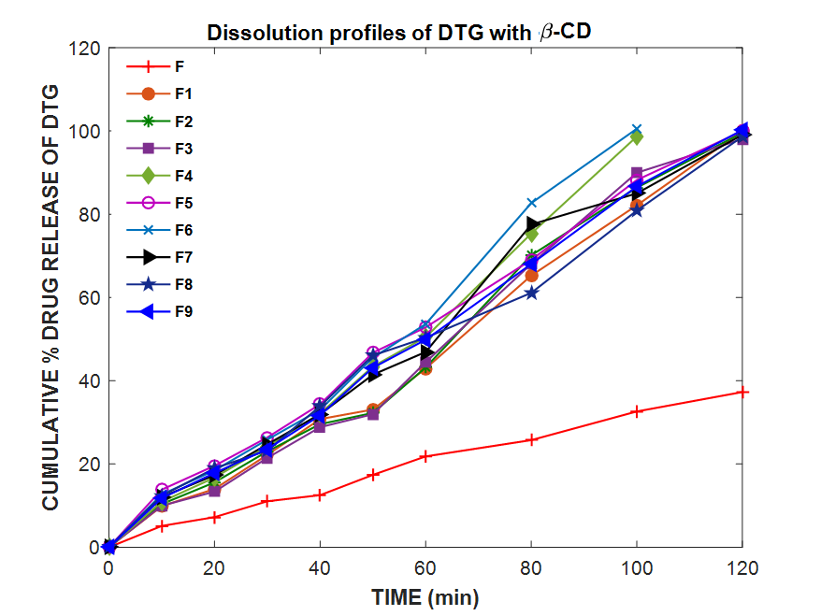

**Table 3.5.2.2.1.1: Dissolution profiles of DTG and DTG-β-CD complexes prepared by the physical mixing, kneading and solvent evaporation methods**

|  |  |  |  |  |  |  |  |  |  |  |
| --- | --- | --- | --- | --- | --- | --- | --- | --- | --- | --- |
| **TIME**  **(min)** | **CUMULATIVE % DRUG RELEASE OF DTG\*** | | | | | | | | | |
| **F** | **F1** | **F2** | **F3** | **F4** | **F5** | **F6** | **F7** | **F8** | **F9** |
| 10 | 6.03± 0.22 | 12.31±0.64 | 16.32±0.75 | 14.72±0.01 | 25.95±0.70 | 27.38± 0.06 | 26.73±0.25 | 25.84±0.67 | 24.33±0.51 | 26.34±0.49 |
| 20 | 11.08±0.21 | 19.11±0.17 | 26.82±0.53 | 27.24±0.37 | 38.67±0.04 | 36.00±0.71 | 35.41±0.12 | 33.19±0.65 | 38.27±0.49 | 39.75±0.36 |
| 30 | 15.09±0.25 | 22.15±0.28 | 38.82±0.51 | 33.78±0.92 | 42.04±0.57 | 49.03±0.22 | 48.39±0.29 | 50.63±0.08 | 47.52±0.32 | 49.03±0.24 |
| 40 | 18.72±0.32 | 48.23±0.59 | 52.88±0.27 | 53.12±0.06 | 56.83±0.23 | 60.33±0.74 | 59.80±0.09 | 54.18±0.23 | 55.82±0.14 | 60.89±0.88 |
| 50 | 23.97±0.53 | 56.41±0.91 | 61.31±0.24 | 72.30±0.95 | 70.04±0.91 | 71.88±0.29 | 73.92±0.40 | 76.88±1.90 | 74.54±1.60 | 75.19±0.34 |
| 60 | 28.23±0.36 | 78.04±0.62 | 80.05±0.03 | 81.15±0.20 | 82.13±0.24 | 84.23±0.46 | 83.52±0.18 | 82.46±0.77 | 83.17±0.14 | 82.11±0.45 |
| 65 | 32.56±0.15 | 84.52±0.66 | 83.35±0.24 | 85.02±0.62 | 86.63±0.85 | 87.25±0.26 | 88.58±0.56 | 86.02±0.05 | 85.99±0.37 | 85.27±0.62 |
| 70 | 37.11±0.24 | 88.34±0.12 | 91.38±0.05 | 93.77±0.35 | 94.32±0.95 | 95.45±0.82 | 95.23±0.75 | 94.22±0.45 | 90.06±0.35 | 92.81±0.13 |
| 75 | 39.04±0.43 | 96.93±0.02 | 94.71±0.18 | 97.01±0.42 | 97.11±0.13 | 100.98±0.69 | 99.82±0.09 | 99.62±0.01 | 99.15±1.01 | 97.23±0.33 |
| 80 | 41.62±0.33 | 100.14±0.67 | 99.57±0.86 | 98.54±0.02 | 100.74±0.89 | - | - | - | - | 100.23±0.67 |

* mean ±S.D, n=3

**C:\Users\user\Desktop\prasanti Plots\23 Dec 2019 Plots\Dissolution Plots\F1-F9\FigF1F9.emf**

**Figure 3.5.2.2.1.1: Dissolution profiles of DTG and DTG-β-CD complexes prepared by the physical mixing, kneading and solvent evaporation methods**

**C:\Users\user\Desktop\prasanti Plots\23 Dec 2019 Plots\First Order Plots\F1F9\F1F9.emf**

**Figure 3.5.2.2.1.2: First order dissolution plots of DTG and DTG-β-CD complexes prepared by the physical mixing, kneading and solvent evaporation methods**

**Table 3.5.2.2.1.2: Dissolution profiles of DTG, DTG-β-CD-PVP K30, DTG-β-CD-PEG 6000 and DTG-β-CD-soluplus complex systems prepared by the optimized kneading method**

|  |  |  |  |  |  |  |  |  |  |  |
| --- | --- | --- | --- | --- | --- | --- | --- | --- | --- | --- |
| **TIME**  **(min)** | **CUMULATIVE % DRUG RELEASE OF DTG\*** | | | | | | | | | |
| **F** | **F10** | **F11** | **F12** | **F13** | **F14** | **F15** | **F16** | **F17** | **F18** |
| 10 | 6.03±0.22 | 42.71±0.25 | 39.42±0.41 | 41.17±0.57 | 35.99±0.38 | 36.41±0.87 | 37.67±0.38 | 46.11±0.14 | 45.82±0.16 | 48.27±0.54 |
| 20 | 11.08±0.21 | 58.03±0.12 | 47.77±0.66 | 56.75±0.15 | 45.06±0.30 | 47.25±0.25 | 51.92±0.96 | 53.19±0.97 | 55.55±0.98 | 58.24±0.22 |
| 30 | 15.09±0.25 | 70.89±0.38 | 68.21±1.0 | 71.49±0.62 | 57.61±0.33 | 62.81±0.52 | 67.08±0.71 | 68.21±0.17 | 73.72±0.10 | 77.06±0.45 |
| 40 | 18.72±0.32 | 79.15±0.24 | 80.16±0.01 | 87.19±0.21 | 73.34±0.64 | 70.04±0.96 | 72.95±0.58 | 75.91±0.37 | 87.69±0.54 | 84.91±0.83 |
| 50 | 23.97±0.53 | 89.69±0.35 | 88.27±0.77 | 90.64±0.56 | 84.23±0.43 | 79.15±0.87 | 83.03±0.23 | 86.30±0.25 | 92.33±0.09 | 91.00±0.97 |
| 60 | 28.23±0.36 | 93.55±0.07 | 92.70±0.42 | 94.11±0.31 | 89.09±0.27 | 87.46±1.80 | 90.72±0.09 | 95.44±0.80 | 95.23±0.16 | 96.80±0.21 |
| 65 | 32.56±0.15 | 95.84±0.69 | 96.59±0.85 | 96.00±0.62 | 96.86±0.33 | 94.19±0.13 | 93.85±0.04 | 98.79±0.74 | 100.03±0.63 | 100.07±0.02 |
| 70 | 37.11±0.24 | 99.07±0.80 | 100.23±0.15 | 100.42±0.78 | 98.00±0.23 | 100.19±0.03 | 100.13±0.07 | - | - | - |

* mean ±S.D, n=3

**C:\Users\user\Desktop\prasanti Plots\23 Dec 2019 Plots\Dissolution Plots\F10-F18\FigF10F18.emf**

**Figure 3.5.2.2.1.3: Dissolution profiles of DTG, DTG-β-CD-PVP K30, DTG-β-CD-PEG 6000 and DTG-β-CD- soluplus complex systems prepared by the optimized kneading method**

**C:\Users\user\Desktop\prasanti Plots\21 Nov 2019 plots\First Order Plots\F10F18\F10F18.emf**

**Figure 3.5.2.2.1.4: First order dissolution plots of DTG, DTG-β-CD-PVP K30, DTG-β-CD-PEG 6000 and DTG-β-CD- soluplus complex systems prepared by the optimized kneading method**

**Dissolution data of DTG with HP-β-CD**

The dissolution profiles of pure drug DTG and inclusion complexes with HP-β-CD prepared by the physical mixing, kneading and solvent evaporation methods in 0.1 N HCl and pH 6.8 phosphate buffer are given in **Table 3.5.2.2.2.1** and shown in **Figure 3.5.2.2.2.1** and **3.5.2.2.2.2**. Dissolution profiles of ternary complexes prepared by the optimized kneading method with the addition of hydrophilic polymers pH 6.8 phosphate buffer are given in **Table 3.5.2.2.2.2** and shown in **Figure 3.5.2.2.2.3** and **3.5.2.2.2.4**.

**Dissolution profiles of DTG and DTG-HP-β-CD complexes prepared by the physical mixing, kneading and solvent evaporation methods**

|  |  |  |  |  |  |  |  |  |  |  |
| --- | --- | --- | --- | --- | --- | --- | --- | --- | --- | --- |
| **TIME**  **(min)** |  | **CUMULATIVE % DRUG RELEASE OF DTG\*** | | | | | | | | |
| **F** | **F19** | **F20** | **F21** | **F22** | **F23** | **F24** | **F25** | **F26** | **F27** |
| 10 | 5.12±0.17 | 11.79±0.23 | 13.15±0.92 | 11.06±0.73 | 16.97±0.16 | 17.91±0.06 | 18.24±0.12 | 18.01±0.42 | 16.72±0.98 | 18.95±0.68 |
| 20 | 7.23±0.29 | 17.54±0.13 | 18.33±0.64 | 16.62±0.84 | 22.72±0.07 | 23.35±0.98 | 24.18±0.99 | 23.67±0.26 | 25.22±0.75 | 21.83±0.94 |
| 30 | 11.04±0.58 | 28.16±0.33 | 27.86±0.95 | 28.91±0.17 | 34.47±0.26 | 33.72±0.87 | 35.63± 0.65 | 31.38±0.73 | 34.12±0.16 | 33.08±0.08 |
| 40 | 12.51±0.04 | 31.78±0.15 | 35.39±0.71 | 37.04±0.06 | 41.32±0.11 | 39.53±0.85 | 42.73±0.34 | 39.44±0.12 | 41.36±0.22 | 40.13±0.21 |
| 50 | 17.38±0.55 | 48.45±0.07 | 47.97±0.66 | 46.59±0.24 | 51.83±0.04 | 45.53±0.92 | 50.28±0.82 | 46.51±0.70 | 50.24±0.33 | 49.62±0.78 |
| 60 | 21.82±0.27 | 52.24±0.93 | 53.32±0.47 | 50.06±0.58 | 55.01±0.95 | 58.28±0.26 | 56.91±0.52 | 57.34±0.87 | 55.33±0.79 | 54.01±0.41 |
| 80 | 25.73±0.07 | 75.08±0.29 | 69.99±0.60 | 65.28±0.79 | 82.04±0.31 | 79.28±0.12 | 71.17±0.64 | 78.21±0.47 | 70.51±0.61 | 65.14±0.38 |
| 90 | 29.14±0.73 | 83.16±0.69 | 84.21±0.40 | 79.32±0.36 | 99.09±0.58 | 100.01±0.43 | 85.01±0.50 | 98.01±0.70 | 85.46±0.66 | 82.37±0.34 |
| 100 | 32.62±0.59 | 99.84±1.11 | 100.73±0.27 | 100.48±0.08 | - | - | 100.92±0.49 | - | 99.62±0.14 | 100.36±0.51 |

* mean ±S.D, n=3

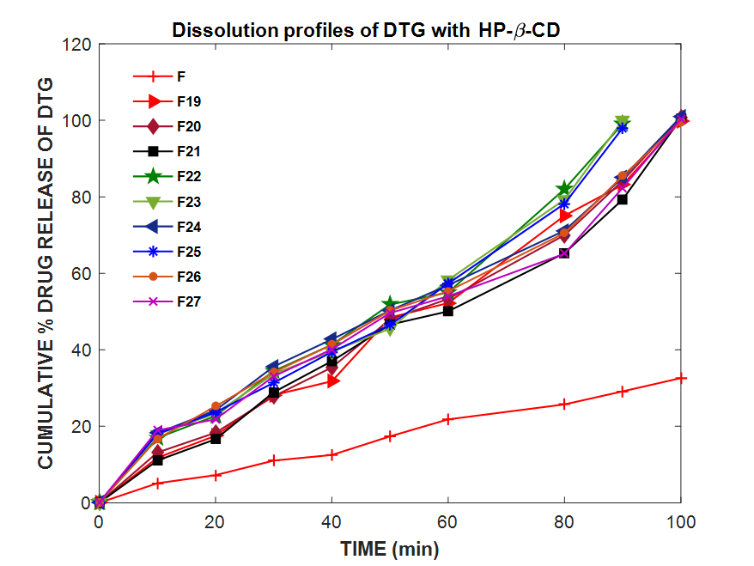

**Table 3.5.2.2.2: Dissolution profiles of DTG and DTG-HP-β-CD complexes prepared by the physical mixing, kneading and solvent evaporation methods**

|  |  |  |  |  |  |  |  |  |  |  |
| --- | --- | --- | --- | --- | --- | --- | --- | --- | --- | --- |
| **TIME**  **(min)** | **CUMULATIVE % DRUG RELEASE OF DTG\*** | | | | | | | | | |
| **F** | **F19** | **F20** | **F21** | **F22** | **F23** | **F24** | **F25** | **F26** | **F27** |
| 10 | 6.03±0.22 | 23.28±0.55 | 24.44±1.2 | 26.86±0.16 | 39.35±0.54 | 38.24±0.51 | 36.34±0.30 | 35.73±0.96 | 38.86±0.12 | 34.44±0.26 |
| 20 | 11.08±0.21 | 38.24±0.77 | 35.56±0.19 | 36.43±0.45 | 49.19±0.75 | 50.07±0.63 | 48.52±0.70 | 46.66±0.98 | 51.41±0.52 | 48.47±1.50 |
| 30 | 15.09±0.25 | 46.88±0.38 | 42.72±1.75 | 49.75±0.91 | 58.30±0.46 | 65.18±0.17 | 63.27±0.14 | 62.07±0.03 | 62.18±0.17 | 65.66±0.87 |
| 40 | 18.72±0.32 | 58.12±0.18 | 56.09±0.45 | 58.07±0.16 | 70.98±0.83 | 74.19±1.40 | 77.47±0.60 | 75.69±0.09 | 73.07±0.38 | 74.67±1.1 |
| 50 | 23.97±0.53 | 69.33±0.99 | 74.45±1.06 | 79.62±0.08 | 81.36±0.68 | 86.81±0.31 | 87.82±0.24 | 80.68±0.36 | 86.28±0.05 | 86.54±0.83 |
| 60 | 28.23±0.36 | 84.19±0.90 | 85.28±0.44 | 87.16±0.81 | 92.97±0.53 | 91.24±0.01 | 90.70±0.39 | 90.47±0.75 | 92.11±0.63 | 91.84±0.38 |
| 65 | 32.56±0.15 | 90.55±0.32 | 88.06±0.14 | 91.01±0.54 | 95.78±0.53 | 94.26±0.01 | 93.21±0.77 | 95.32±0.25 | 95.07±0.51 | 93.06±0.88 |
| 70 | 37.11±0.24 | 94.38±0.37 | 93.89±0.30 | 97.57±0.85 | 100.31±0.97 | 97.14±0.37 | 96.36±0.81 | 98.99±0.83 | 99.25±0.03 | 96.59±0.17 |
| 75 | 39.04±0.43 | 99.09±0.59 | 98.01±0.36 | 100.99±0.44 | - | 100.92±0.42 | 99.98±0.37 | - | - | 100.44±0.91 |

* mean ±S.D, n=3

**C:\Users\user\Desktop\prasanti Plots\23 Dec 2019 Plots\Dissolution Plots\F19-F27\F19F27.emf**

**Figure 3.5.2.2.2.1: Dissolution profiles of DTG and DTG-HP-β-CD complexes prepared by the physical mixing, kneading and solvent evaporation methods**

**C:\Users\user\Desktop\prasanti Plots\23 Dec 2019 Plots\First Order Plots\F10F18\F10F18.emf**

**Figure 3.5.2.2.2.2: First order dissolution plots of DTG and DTG-HP-β-CD complexes prepared by the physical mixing, kneading and solvent evaporation methods**

**Table 3.5.2.2.2.2: Dissolution profiles of DTG, DTG-HP-β-CD-PVP K30, DTG-HP-β-CD-PEG 6000 and DTG-HP-β-CD- soluplus complex systems prepared by the optimized kneading method**

|  |  |  |  |  |  |  |  |  |  |  |
| --- | --- | --- | --- | --- | --- | --- | --- | --- | --- | --- |
| **TIME**  **(min)** | **CUMULATIVE % DRUG RELEASE OF DTG\*** | | | | | | | | | |
| **F** | **F28** | **F29** | **F30** | **F31** | **F32** | **F33** | **F34** | **F35** | **F36** |
| 10 | 6.03±0.22 | 54.33±1.01 | 51.92±0.62 | 53.50±0.27 | 48.72±0.12 | 49.75±0.91 | 50.07±0.36 | 56.08±0.64 | 58.24±0.22 | 55.42±0.14 |
| 20 | 11.08±0.21 | 69.09±0.21 | 63.22±0.64 | 67.38±0.41 | 56.71±0.28 | 58.82±0.01 | 60.08±0.65 | 73.25±0.42 | 76.67±0.54 | 71.49±0.15 |
| 30 | 15.09±0.25 | 73.28±0.26 | 70.95±0.13 | 79.03±0.20 | 61.35±0.16 | 63.67±0.86 | 71.87±0.88 | 87.19±0.21 | 89.36±0.47 | 85.16±0.33 |
| 40 | 18.72±0.32 | 85.91±0.13 | 79.51±0.14 | 86.53±0.23 | 70.40±0.81 | 72.59±0.04 | 80.71±0.04 | 89.27±0.55 | 91.84±0.83 | 87.81±0.90 |
| 50 | 23.97±0.53 | 92.43±0.71 | 88.57±0.52 | 91.10±0.26 | 84.23±0.34 | 82.28±0.21 | 86.23±0.85 | 95.80±0.21 | 96.32±0.11 | 95.73±0.44 |
| 60 | 28.23±0.36 | 97.43±0.31 | 96.03±0.19 | 96.70±0.94 | 93.96±0.75 | 95.97±0.21 | 97.87±0.5 | 99.77±0.04 | 100.45±0.24 | 98.45±0.12 |
| 65 | 32.56±0.15 | 100.97±0.36 | 100.49±0.47 | 99.87±0.42 | 99.59±0.06 | 98.99±0.52 | 99.15±0.67 | - | - | 100.17±0.16 |

* mean ±S.D, n=3

**C:\Users\user\Desktop\prasanti Plots\23 Dec 2019 Plots\Dissolution Plots\F28-F36\FigF28F36.emf**

**Figure 3.5.2.2.2.3: Dissolution profiles of DTG, DTG-HP-β-CD-PVP K30, DTG-HP-β-CD-PEG 6000 and DTG-HP-β-CD- soluplus complex systems prepared by the optimized kneading method**

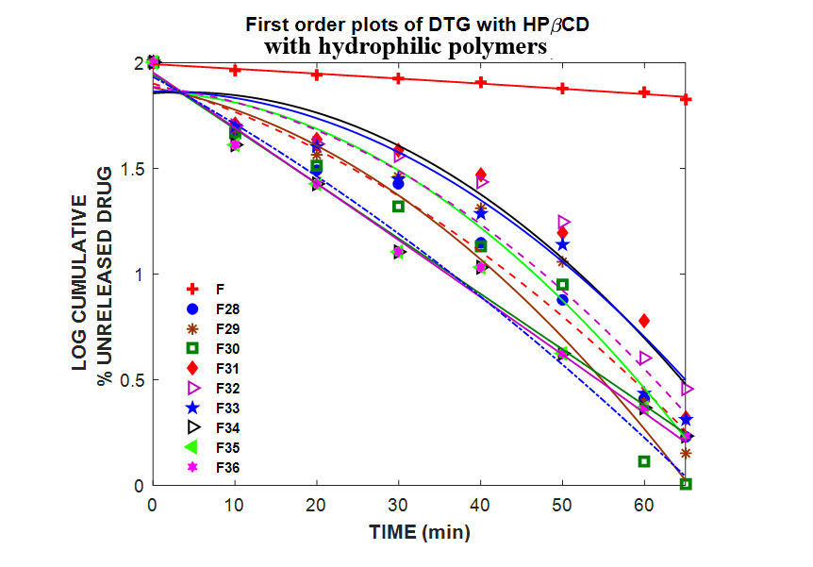

**Figure 3.5.2.2.2.4: First orderdissolution plots of DTG, DTG-HP-β-CD-PVP K30, DTG-HP-β-CD-PEG 6000 and DTG-HP-β-CD- soluplus complex systems prepared by the optimized kneading method**

**DISSOLUTION RATE ENHANCEMENT**

The enhancement in the dissolution rate of CBS and DTG by β-CD and HP- β-CD complex systems was calculated from the ratio of K1 of CD complex systems and uncomplexed drug both in the presence and absence of hydrophilic polymers in 0.1N HCl and pH 6.8 phosphate buffer are shown in **Table 3.5.2.3.1** to **Table 3.5.2.3.4.**

**Table 3.5.2.3.1: Enhancement in the dissolution rate of CBS by various β-CD and HP- β-CD complex systems in 0.1 N HCl**

|  |  |  |  |
| --- | --- | --- | --- |
| **Complex systems** | **Increase in K1\***  **(No. of folds)** | **Complex systems** | **Increase in K1\***  **(No. of folds)** |
| C1 | 5.34 | C19 | 6.95 |
| C2 | 5.39 | C20 | 6.69 |
| C3 | 5.19 | C21 | 6.65 |
| C4 | 5.84 | C22 | 8.95 |
| C5 | 6.65 | C23 | 8.15 |
| C6 | 6.15 | C24 | 8.76 |
| C7 | 6.23 | C25 | 8.39 |
| C8 | 5.89 | C26 | 8.29 |
| C9 | 5.65 | C27 | 8.15 |
| C10 | 9.00 | C28 | 11.52 |
| C11 | 9.60 | C29 | 11.50 |
| C12 | 8.95 | C30 | 11.56 |
| C13 | 8.00 | C31 | 10.56 |
| C14 | 8.75 | C32 | 10.54 |
| C15 | 8.30 | C33 | 10.26 |
| C16 | 11.00 | **C34** | **14.95** |
| C17 | 11.91 | C35 | 14.45 |
| C18 | 10.50 | C36 | 14.30 |

*Ratio of K1 of CD complex systems and uncomplexed CBS

**Table 3.5.2.3.2: Enhancement in the dissolution rate of DTG by various β-CD and HP- β-CD complex systems**

|  |  |  |  |
| --- | --- | --- | --- |
| **Complex systems** | **Increase in K1\***  **(No. of folds)** | **Complex systems** | **Increase in K1\***  **(No. of folds)** |
| F1 | 5.41 | F19 | 6.08 |
| F2 | 6.66 | F20 | 6.66 |
| F3 | 6.04 | F21 | 7.33 |
| F4 | 5.64 | F22 | 8.33 |
| F5 | 7.50 | F23 | 8.20 |
| F6 | 6.18 | F24 | 8.54 |
| F7 | 6.22 | F25 | 7.77 |
| F8 | 6.12 | F26 | 8.52 |
| F9 | 6.93 | F27 | 8.75 |
| F10 | 9.16 | F28 | 11.45 |
| F11 | 9.25 | F29 | 11.04 |
| F12 | 10.06 | F30 | 13.22 |
| F13 | 7.77 | F31 | 8.33 |
| F14 | 7.60 | F32 | 9.55 |
| F15 | 8.62 | F33 | 10.87 |
| F16 | 9.72 | F34 | 14.04 |
| F17 | 10.83 | **F35** | **14.75** |
| F18 | 11.27 | F36 | 13.27 |

*Ratio of K1 of CD complex systems and uncomplexes DTG

**3.5.3. DISSOLUTION EFFICIENCY**

The dissolution efficiency and the other dissolution parameters like first order dissolution rate constant (K1), half- life (T50 %) of CBS and DTG are given in **Table 3.5.3.1** and **Table 3.5.3.2.** Correlation coefficient (r) values of CBS and DTG in the analysis of dissolution data as per first order are given in **Table 3.5.3.2** and **Table 3.5.3.4.**

**Table 3.5.3.1: Dissolution parameters of CBS with various β-CD and HP-β-CD complexes in 0.1 N HCl**

|  |  |  |  |  |  |  |  |  |  |
| --- | --- | --- | --- | --- | --- | --- | --- | --- | --- |
| **Complex**  **Systems** | **Complex systems** | | | | **HP-β-CD Complexes** | | | | |
| **DE30%** | **T50**  **(min)** | **K0** | **K1**  **(min-1)** |  | **DE30%** | **T50**  **(min)** | **K0** | **K1**  **(min-1)** |
| Pure drug | 14.56 | 150.65 | 0.423 | 0.0046 |  |  |  | **2** | **1** |
| C1 | 24.98 | 30.17 | 1.237 | 0.0246 | C19 | 27.04 | 21.65 | 1.216 | 0.0320 |
| C2 | 25.42 | 29.84 | 1.202 | 0.0248 | C20 | 26.40 | 22.50 | 1.125 | 0.0308 |
| C3 | 24.69 | 28.99 | 1.208 | 0.0239 | C21 | 27.16 | 22.64 | 1.205 | 0.0306 |
| C4 | 28.21 | 25.76 | 1.194 | 0.0269 | C22 | 31.81 | 18.78 | 1.237 | 0.0375 |
| C5 | 29.27 | 22.64 | 1.231 | 0.0306 | C23 | 31.86 | 16.82 | 1.219 | 0.0412 |
| C6 | 29.07 | 24.48 | 1.202 | 0.0283 | C24 | 31.69 | 17.19 | 1.222 | 0.0403 |
| C7 | 29.60 | 24.14 | 1.191 | 0.0287 | C25 | 31.10 | 17.95 | 1.237 | 0.0386 |
| C8 | 29.38 | 25.57 | 1.151 | 0.0271 | C26 | 29.97 | 18.28 | 0.982 | 0.0379 |
| C9 | 29.01 | 26.65 | 1.157 | 0.0260 | C27 | 30.37 | 18.48 | 1.013 | 0.0375 |
| C10 | 32.69 | 16.73 | 1.222 | 0.0414 | C28 | 36.95 | 13.07 | 0.997 | 0.053 |
| C11 | 33.31 | 15.67 | 1.198 | 0.0442 | C29 | 37.31 | 13.01 | 1.047 | 0.0529 |
| C12 | 33.98 | 16.82 | 1.147 | 0.0412 | C30 | 37.20 | 14.43 | 1.002 | 0.0485 |
| C13 | 30.51 | 18.83 | 1.180 | 0.0368 | C31 | 36.44 | 14.43 | 1.053 | 0.0485 |
| C14 | 32.09 | 16.82 | 1.175 | 0.0412 | C32 | 34.39 | 14.28 | 1.052 | 0.0481 |
| C15 | 31.83 | 18.14 | 1.192 | 0.0382 | C33 | 34.12 | 14.68 | 1.024 | 0.0475 |
| C16 | 33.17 | 13.69 | 1.113 | 0.0506 | C34 | 39.41 | 10.07 | 0.998 | 0.0688 |
| C17 | 33.08 | 12.64 | 1.127 | 0.0548 | C35 | 38.57 | 10.42 | 0.984 | 0.0665 |
| C18 | 33.48 | 14.34 | 1.128 | 0.0483 | C36 | 37.78 | 10.31 | 0.870 | 0.0672 |

**Table 3.5.3.2: Dissolution parameters of DTG with various β-CD and HP-β-CD complexes in 0.1 N HCl**

|  |  |  |  |  |  |  |  |  |  |
| --- | --- | --- | --- | --- | --- | --- | --- | --- | --- |
| **β-CD-Complexes** | **DE30%** | **T50**  **(min)** | **K0** | **K1**  **(min-1)** | **HP-β-CD Complexes** | **DE30%** | **T50**  **(min)** | **K0** | **K1**  **(min-1)** |
| Pure drug | 16.29 | 173.25 | 0.457 | 0.0048 |  |  |  |  |  |
| F1 | 22.43 | 27.67 | 1.730 | 0.0026 | F19 | 31.26 | 23.73 | 1.171 | 0.0292 |
| F2 | 27.09 | 25.61 | 1.154 | 0.0320 | F20 | 30.76 | 21.65 | 1.205 | 0.0320 |
| F3 | 26.73 | 27.55 | 1.145 | 0.0360 | F21 | 31.21 | 19.68 | 1.216 | 0.0352 |
| F4 | 31.84 | 24.25 | 1.128 | 0.0271 | F22 | 34.89 | 17.32 | 1.065 | 0.0400 |
| F5 | 31.18 | 23.89 | 1.145 | 0.0290 | F23 | 35.50 | 17.35 | 1.091 | 0.0420 |
| F6 | 30.96 | 23.33 | 1.217 | 0.0297 | F24 | 36.18 | 16.90 | 1.145 | 0.0410 |
| F7 | 30.27 | 23.17 | 1.194 | 0.0299 | F25 | 35.37 | 18.57 | 1.114 | 0.0373 |
| F8 | 31.40 | 23.57 | 1.174 | 0.0294 | F26 | 35.60 | 16.94 | 1.102 | 0.0409 |
| F9 | 32.00 | 24.31 | 1.132 | 0.0285 | F27 | 34.32 | 16.50 | 1.165 | 0.0420 |
| F10 | 36.89 | 18.57 | 1.020 | 0.0440 | F28 | 39.92 | 12.60 | 0.845 | 0.0550 |
| F11 | 34.57 | 20.86 | 1.142 | 0.0444 | F29 | 38.75 | 13.07 | 0.882 | 0.0530 |
| F12 | 36.37 | 18.93 | 1.094 | 0.0483 | F30 | 39.01 | 11.91 | 0.868 | 0.0635 |
| F13 | 34.12 | 15.75 | 1.151 | 0.0373 | F31 | 37.89 | 17.32 | 0.908 | 0.0402 |
| F14 | 34.40 | 15.60 | 1.025 | 0.0317 | F32 | 38.26 | 16.11 | 0.888 | 0.0431 |
| F15 | 35.30 | 18.93 | 1.045 | 0.0366 | F33 | 37.87 | 13.37 | 0.920 | 0.0518 |
| F16 | 36.36 | 14.83 | 1.002 | 0.0467 | F34 | 39.60 | 12.09 | 0.808 | 0.0573 |
| F17 | 36.45 | 13.32 | 1.071 | 0.0520 | F35 | 40.16 | 10.66 | 0.788 | 0.0659 |
| F18 | 36.98 | 12.80 | 0.988 | 0.0541 | F36 | 39.41 | 10.87 | 0.825 | 0.0637 |

**Table 3.5.3.3: Correlation coefficient (r) values of CBS in the analysis of dissolution data as per Zero order and First order in 0.1 N HCl**

|  |  |  |  |  |  |
| --- | --- | --- | --- | --- | --- |
| **Complex systems** | **Zero order** | **First order** | **Complex systems** | **Zero order** | **First order** |
| Pure drug | 0.990 | 0.997 |  |  |  |
| C1 | 0.974 | 0.986 | C19 | 0.992 | 0.995 |
| C2 | 0.940 | 0.969 | C20 | 0.983 | 0.991 |
| C3 | 0.966 | 0.982 | C21 | 0.991 | 0.995 |
| C4 | 0.970 | 0.984 | C22 | 0.987 | 0.993 |
| C5 | 0.977 | 0.988 | C23 | 0.994 | 0.996 |
| C6 | 0.996 | 0.997 | C24 | 0.988 | 0.993 |
| C7 | 0.982 | 0.990 | C25 | 0.984 | 0.991 |
| C8 | 0.975 | 0.987 | C26 | 0.982 | 0.990 |
| C9 | 0.974 | 0.986 | C27 | 0.994 | 0.996 |
| C10 | 0.996 | 0.997 | C28 | 0.987 | 0.993 |
| C11 | 0.985 | 0.992 | C29 | 0.977 | 0.988 |
| C12 | 0.985 | 0.991 | C30 | 0.968 | 0.983 |
| C13 | 0.986 | 0.992 | C31 | 0.985 | 0.992 |
| C14 | 0.989 | 0.994 | C32 | 0.981 | 0.990 |
| C15 | 0.994 | 0.996 | C33 | 0.993 | 0.995 |
| C16 | 0.988 | 0.993 | C34 | 0.997 | 0.998 |
| C17 | 0.974 | 0.986 | C35 | 0.988 | 0.993 |
| C18 | 0.971 | 0.983 | C36 | 0.970 | 0.984 |

**Table 3.5.3.4: Correlation coefficient (r) values of DTG in the analysis of dissolution data as per Zero order and First order in 0.1 N HCl**

|  |  |  |  |  |  |
| --- | --- | --- | --- | --- | --- |
| **Complex systems** | **Zero order** | **First order** | **Complex systems** | **Zero order** | **First order** |
| Pure drug | 0.989 | 0.997 |  |  |  |
| F1 | 0.969 | 0.984 | F19 | 0.994 | 0.996 |
| F2 | 0.990 | 0.994 | F20 | 0.984 | 0.991 |
| F3 | 0.980 | 0.989 | F21 | 0.986 | 0.992 |
| F4 | 0.984 | 0.991 | F22 | 0.998 | 0.998 |
| F5 | 0.998 | 0.998 | F23 | 0.983 | 0.991 |
| F6 | 0.997 | 0.998 | F24 | 0.970 | 0.984 |
| F7 | 0.973 | 0.986 | F25 | 0.979 | 0.989 |
| F8 | 0.986 | 0.992 | F26 | 0.992 | 0.995 |
| F9 | 0.994 | 0.996 | F27 | 0.975 | 0.987 |
| F10 | 0.969 | 0.984 | F28 | 0.972 | 0.985 |
| F11 | 0.954 | 0.976 | F29 | 0.996 | 0.997 |
| F12 | 0.934 | 0.966 | F30 | 0.960 | 0.979 |
| F13 | 0.984 | 0.991 | F31 | 0.979 | 0.989 |
| F14 | 0.987 | 0.993 | F32 | 0.982 | 0.990 |
| F15 | 0.973 | 0.986 | F33 | 0.994 | 0.996 |
| F16 | 0.992 | 0.995 | F34 | 0.998 | 0.987 |
| F17 | 0.940 | 0.969 | F35 | 0.991 | 0.998 |
| F18 | 0.951 | 0.975 | F36 | 0.987 | 0.990 |

**DISCUSSIONS**

**PHASE SOLUBILITY STUDIES**

**Clopidogrel bisulphate**

The phase solubility diagrams for the complex formation between CBS and β-CD/HP-β-CD are presented in **Tables 3.2.1** & **3.2.2** and in **Figures 3.2.1** & **3.2.2** the solubility of clopidogrel bisulphate concentration of β-CD (0-12mm) and HP-β-CD (0-12mm) alone and in the presence of hydrophylic polymers (taken on the basis of %W/V) are given in these Tables. A study of these Tables and Figures allows for the following observations.

* The aqueous solubility of the drug increases linearity as a function of CD concentration.
* The solubility diagrams of CBS in the presence of β-CD and HP-β-CD may be classified as Ac type according to Higuchi and Connors this may be attributed to the formation of soluble 1:1 CBS: CD inclusion complexes.
* The cavity size of HP-β-CD seems to be more suitable for the entrapment of the drug as this CD is providing greater solubilisation effect.
* The slopes of the straight lines are less than 1 in all cases. Hence, the increase in solubility may be attributed to the formation of 1:1M complex in solution with β-CD and HP-β-CD.

**Hydrophilic polymers**

* The inclusion of the hydrophilic polymers into the CD complexes of the drug CBS, further enhanced the effect of enhancing the solubility. The enhancement in the solubility was found to be increasing linearly with increasing concentration of the polymers, for all the three polymers.
* The order of enhancement in the complexation efficiency was found to be soluplus>PVPK30>PEG 6000 for the complexation with both CDs.

**Apparent stability constants**

* The apparent stability constant (Kc) for all the complexes was calculated from the slope of the corresponding linear plot of the phase solubility diagram
* **T**he estimated Kc values of various complexes of CBS are given in **Table 3.2.5** and showed that all the complexes are quite stable.
* The values for β-CD complexes of CBS were in the range of 161 to 404. The increase in solubility, in terms of folds of increase with the addition of the three polymers, PEG 6000, PVPK 30 and soluplus was 1.59, 2.02 and 2.50 respectively. The same values for HP-β-CD complexes were 169 to 444 & 1.93, 2.4 and 2.62 for PEG 6000, PVPK 30 and soluplus in terms of folds of increase in solubility respectively.
* It may be concluded from a study of the data given in **Tables 3.2.1** & **3.2.2** and **3.2.5** and the graphs shown in Figures **3.2.1** and **3.2.2** that stable complexes of CBS were formed with β-CD and HP-β-CD and the stability was further enhanced in the presence of hydrophilic polymers. The order of the polymers in enhancing the complexation efficiency was soluplus>PVPK 30>PEG 6000 for both the CDs.

**Solubilising Efficiency**

* The solubilising efficiency of the complexes was calculated for CBS complexes as the ratio between the solubility of the drug in aqueous solutions (12mm) of CD and in water. The values of solubilising efficiency of CBS complexes are shown in **Table 3.2.6.**
* Complexation with β-CD and HP-β CD enhanced the solubility of CBS by 2.76 folds and 3.06 folds respectively.
* When hydrophilic polymers were added to these complexes there was even more enhancement in solubility and for PEG 6000, PVPK 30 and soluplus, these values were formed to be 4.83, 6.69 and 7.83 respectively for β CD complexes. The corresponding values for HP-β CD were found to be 5.16, 6.98 and 8.44.

**Dolutegravir sodium**

* The results obtained in the phase solubility studies of the drug dolutegravir sodium are presented in **Tables 3.2.3** & **3.2.4** and in **Figures 3.2.3** and **3.2.4.**
* All the conclusions drawn in the case of CBS were also completely identical in the case of the drug candidate DTG.
* The rise in the values of the stability constants of DTG when it was complexed with β CD was 1.75, 2.29 and 2.53 folds for PEG 6000, PVPK 30 and soluplus respectively.
* Complexation with β- CD and HP-β-CD enhanced the solubiliding efficiency of DTG by 3.74 and 3.90 folds.
* The hydrophylic polymers, PEG 6000, PVPK 30 and soluplus, upon adding to DTG-β CD complexes enhanced solubility of DTG by 4.70, 6.54 and 7.92 folds. Upon adding to HP-β-CD complexes they raised the solubility of DTG by 5.27, 7.12 and 10.70 folds respectively.

Hence, it may be concluded by a study of all the three parameters; phases solubility graphs and solubility date, stability constants and solubilising efficiency values, that for the drugs CBS and DTG.

* Complexation of CDs enhanced solubility.
* HP-β-CD caused more enhancement in solubility.
* Addition of polymers to complexes enhanced then solubilisation capacities.
* The order of enhancement was Soluplus>PVPK 30>PEG 6000.

**DSC**

The thermal behaviour of CD-inclusion complexes was studied using DSC in order to confirm the formation of inclusion complex. When the guest molecules are incorporated in the CD-cavity or in the lattice, their melting points usually shifted to a different temperature or disappear within the temperature range where the CD-lattice is decomposed.

**CLOPIDOGREL BISULPHATE**

The DSC thermograms showed an endothermic peak for CBS at 160.48 0C corresponding to its melting point. In the thermograms of CBS-β-CD & HP-β-CD, the drug peaks were shifted to 156.7 0C and 153.20C respectively. In the presence of soluplus, the endothermic peaks were further reduced to 140.30C and 130.120C. The endothermic peak at 130.120C was markedly reduced in D-HP-β-CD- soluplus system indicating the absence of crystal drug and its complete complexation with HP-β-CD.

**DOLUTEGRAVIR SODIUM**

The DSC thermograms showed an endothermic peak for DTG at 196 0C corresponding to their melting points. In the thermograms of DTG-β-CD & HP-β-CD, the drug peaks were shifted to 188.130C and 181.20C, respectively. In the presence of soluplus the endothermic peaks were further reduced to 167.20C and 157.6 0C. The endothermic peak at 157.6 0C was markedly reduced in D-HP-β-CD-soluplus system indicating the absence of crystal drug and its complete complexation with HP-β-CD.

**X-RD**

The crystallinity can be determined by comparing some representative peak heights in the diffraction patterns of the binary and ternary systems with those of reference. The relationship used for the calculation of cystallinity was a relative degree of crystallinity (RDC).

% RDC= Isam/Iref

Isam= peak height of sample under investigation

Iref= peak height at the same angle for the reference with the highest intensity

**CLOPIDOGREL BISULPHATE**

The X-RD of CBS exhibited characteristic diffraction peaks at 9.2, 13.51, 14.23, 16.21, 18.24, 19.09, 20.7 and 22.14 ± 0.2o 2θ indicating its crystalline nature.

**DOLUTEGRAVIR SODIUM**

The XRD of DTG exhibited characteristic diffraction peaks at 8.6, 12.7, 14.3, 15.7, 16.8, 18.08, 19.52 and 23.05 ± 0.2o 2θ indicating its crystalline nature.

In the X-RD graphs for both the drugs the diffraction peaks were much reduced in the case of binary (D-β-CD, HP-β-CD) systems and were absent in the case of ternary (D-(β-CD, HP-β-CD) – PVP K30, PEG 6000, soluplus) systems respectively. The disappearance of CBS and DTG crystalline peaks confirmed the stronger drug amorphization and entrapment in β-CD, HP-β-CD due to combined action of β-CD, HP-β-CD and hydrophilic polymers.

The % RDC values of complexes were less than those of the drug in all cases and can be arranged in the order D-β-CD < D-β-CD-PEG 6000 <D-β-CD-PVP K30 < D-β-CD-soluplus, D-HP-β-CD < D-HP-β-CD-PEG 6000 < D-HP-β-CD-PVP K30 <D-HP-β-CD-soluplus. Further, the higher a reduced number of signals that are noticeable in the complexes, of remarkably lowered intensity, indicating a greater amorphousness of the inclusion complex, compared to the molecules (Calabr’O et al, 2004).

**SEM**

The SEM microphotographs of CBS and DTG powder showed crystals of different sizes with smooth surfaces. The smaller crystals seem to have adhered to the surface of the larger ones. In the SEM photographs of kneaded systems, with and without hydrophilic polymers, the crystalline characters of CBS and DTG are absent and the crystals of the components, i.e., CBS and DTG and CDs could not be differentiated. The samples are more homogeneous and the particles in all the systems are all irregular in shape which indicated a good physical interaction of drug particles with CDs and the added hydrophilic polymers. Although SEM technique is inadequate to conclude complex formation, the SEM micrographs support the formation of CD- complexes entrapping of drug particles.

**FT-IR**

**CLOPIDOGREL BISULPHATE**

The main absorption bands of CBS at 1473.76 cm-1, C-H (stretching) of alkyl, 3446.99 cm-1 C-N (stretching), 1669.51 cm-1 C=O (stretching), 595.65 cm-1Ar-Cl (aryl chloride), 2926 cm-1 (orthosubstituted dibenzene) were all observed in the spectra of drug molecules as well as in its CD- complex systems. The FT-IR studies indicated that the characteristic peak of clopidogrel bisulphate which was also present in all the inclusion complexes showed no interaction between the drug molecule, cyclodextrins and hydrophilic polymers.

**DOLUTEGRAVIR SODIUM**

The main absorption bands of DTG at 1757.40 cm-1 C=O, anhydride (stretching), 1536.21cm-1 N-H (secondary amide), 3611cm-1 OH (sharp), 3394cm-1 OH(broad), 2982.72 cm-1& 2919.62 cm-1 CH (stretching) of alkane, 3074.09cm-1 C=H (stretching) were all observed in the spectra of drug molecules as well as in its CD-complex systems. Thus, the observations showed no interactions between the drug molecule, the cyclodextrins and the hydrophilic polymers.

**DRUG CONTENT UNIFORMITY**

The solid inclusion complexes prepared were found to be fine and free flowing and were evaluated for drug content uniformity. Drug content of the inclusion complexes (CBS-β-CD/ HP-β-CD and DTG-β-CD/ HP-β-CD) with hydrophilic polymers was quite uniform and was found to be more in the complexes prepared by kneading method. The percent drug content for CBS and DTG inclusion complexes was found to be in the range **91.02%** to **99.68%** and **91.19%** to **99.87%** respectively. The values of standard deviations were found to be low.

**DISSOLUTION STUDIES**

The dissolution of CBS and DTG was rapid and gave higher percent drug release values from all the cyclodextrin inclusion complexes when compared to pure drug. The dissolution rates were further increased upon the addition of hydrophilic polymers. The dissolution data were fitted into various mathematical models such as first order and zero order to assess the drug release kinetics. The dissolution data obeyed first order kinetic model as well as the correlation coefficient (r) were values observed for CBS and DTG in the analysis of dissolution data. The values of correlation coefficient (r) were found to be more in the case of first order fit than in the case of zero order fit. Hence, it was concluded that the dissolution profiles followed first order kinetics. The corresponding dissolution rates were calculated from the slopes of their corresponding first order linear plots.

All CD complexes exhibited higher rates of dissolution and other dissolution parameters like DE30, K1, T50 and values than the pure drug indicating rapid and higher dissolution from their respective CD complexes. The K1 and DE30 values increased as the proportion of CD in the complex system was increased in each case. The increase in K1 (no. of folds) with various CD systems for CBS and DTG were calculated.

* HP-β-CD gave higher enhancement in the dissolution rate and efficiency when compared to β-CD.
* Complexes prepared by kneading method gave higher dissolution rate and DE30 values than those prepared by solvent evaporation and physical mixing methods.
* The higher dissolution rates and DE30 values observed with kneaded complexes may be due to the better drug-CD inclusion during the kneading process.

Increase in several folds in the dissolution rate of CBS and DTG was observed with the addition of hydrophilic polymers to their cyclodextrin complexes.

CBS-β-CD (1:1.5) kneaded complex gave a **6.65** fold increase in the dissolution rate of CBS, where as in the presence of hydrophilic polymers, the highest folds were **9.60, 8.75** and **11.91** respectively with PVP K30, PEG 6000 and soluplus complexes. Similarly, CBS-HP-β-CD (1:1) kneaded complex gave an **8.95** fold increase in the dissolution rate of CBS, where as in the presence of hydrophilic polymers, the number of times increase (folds) are **11.56, 10.56** and **14.95** for complexes with PVP K30, PEG 6000 and Soluplus respectively. The order of hydrophilic polymers in enhancing the dissolution rate of CBS-CD complexes was SOLUPLUS>PVP K30>PEG 6000 in both the cases, i.e., with β-CD as well as with HP-β-CD. The solid inclusion complexes of β-CD and HP-β-CD with hydrophilic polymers gave higher rates of dissolution, several times higher than those of CBS and its complex with CDs alone.

DTG-β-CD (1:1.5) kneaded complex gave a **7.50** folds increase in the dissolution rate of DTG, whereas in the presence of hydrophilic polymers, the highest “folds” were **10.06, 8.62** and **11.27** respectively with PVP K30, PEG 6000 and soluplus complexes. Similarly, DTG-HP-β-CD (1:2) kneaded complex gave a **8.54** folds increase in the dissolution rate of DTG, where as in the presence of hydrophilic polymers, it gave **13.22, 10.87** and **14.75** folds increase respectively with PVP K30, PEG 6000 and soluplus. The order of hydrophilic polymers in enhancing the dissolution rate of DTG-CD complexes was SOLUPLUS>PVP K30>PEG 6000 in both the cases i.e., with β-CD and HP-β-CD. The solid inclusion complexes of β-CD and HP-β-CD with hydrophilic polymers gave higher rate of dissolution, several times higher than those of DTG and its complex with CDs alone.

Two way analysis of variance was conducted to test whether the difference in mean dissolution efficiency values observed between the three methods of preparation of inclusion complexes, physical mixing, kneading and solvent evaporation method was significant or not, and to test whether the difference observed between the mean dissolution efficiencies at 30 min between CBS-β-CD/ HP-β-CD and DTG-β-CD/ HP-β-CD complexes was significant or not. The analysis revealed that the difference between the methods was significant and the difference between the two types of complexes was also significant. There was an interaction effect between the methods and the types of complexes.

Statistical analysis also revealed that the difference among the three types of ternary complexes, as well as the difference among the three methods was significant. The kneading method was the best among the three attempted methods for both the drugs, HP-β-CD was the better one between the two attempted cyclodextrins and CBS-HP-β-CD-SOLUPLUS (1:1:1) complex was the best among the ternary complexes of CBS and DTG-HP-β-CD-SOLUPLUS (1:2:1.5) complex was the best among the ternary complexes of DTG.

The much enhanced dissolution rate observed with CBS-CD and DTG-CD complexes systems containing hydrophilic polymers is due to the enhancement of complexation and solubilisation efficiencies of cyclodextrins by the added hydrophilic polymers and also due to the stronger drug amorphization and better inclusion due to the combined action of CD and hydrophilic polymers. Because of the enhancement in the presence of hydrophilic polymers, a low amount of CD can be used to get the desired dissolution rate and efficiency.

**CONCLUSION**

Solid inclusion complexes of CBS-β-CD and CBS-HP-β-CD and DTG-β-CD and DTG-HP-β-CD in 1:1, 1:1.5 and 1:2 ratios were prepared with and without hydrophilic polymers ( PVP K30, PEG 6000 and SOLUPLUS) by three methods i.e, physical mixing, kneading and solvent evaporation and were evaluated for dissolution rate and dissolution efficiency. All the CBS-CD and DTG-CD complexes exhibited higher rates of dissolution and dissolution efficiency values than the uncomplexed ones. HP-β-CD gave higher enhancement in the dissolution rate and efficiency when compared to β-CD complexes. Complexes prepared by kneading method gave a higher dissolution rate than those prepared by solvent evaporation and physical mixing methods. The addition of hydrophilic complexes to the CBS-CD and DTG-CD complexes has further enhanced their dissolution rate and efficiency. The order of hydrophilic polymers in enhancing the dissolution rate of CBS and DTG from their CD complexes were **SOLUPLUS> PVP K30> PEG 6000** with both β-CD and HP-β-CD. The solid inclusion complexes of β-CD and HP-β-CD with hydrophilic polymers give higher rates of dissolution, several times higher for both CBS and DTG and their complexes with CDs alone.

**REFERENCES:**

1. **Hig**uchi T., Connors K.A., Phase-solubility techniques, Adv.Anal.Chem.Instr., 4, 117-
2. 122, (1965
3. Higuchi T., Connors K.A., Phase-solubility techniques, Adv.Anal.Chem.Instr., 4, 117-
4. 122, (1965
5. Higuchi T., Connors K.A., Phase-solubility techniques, Adv.Anal.Chem.Instr., 4, 117-
6. 122, (1965
7. Higuchi T and Connors K A. Phase solubility techniques, Advances in Analytical. Chemistry and Instrumentation, 1965; 4:117-122.
8. Ganesh C, Kundan P, Dhananjay G, Shaguftha K and Pramod Y. Preparation and characterization of solid dispersion tablet of furosemide with crospovidone. Research Journal of Pharmacy and Technology, 2008; 1(4): 386-389.
9. Pankaj Kumar S Y, Vikas K, Uday P S, Hans R B and Mazumder B. Physicochemical characterization and *in vitro* dissolution studies of solid dispersions of ketoprofen with PVP K30 and D-mannitol, Saudi Pharmaceutical Journal, 2013; 21(1): 77-84.
10. Van H T, Piel G, Hassorville S H, Evrad B and Dalattre L. Determination of the free/included piroxicam ratio in cyclodextrin complexes: comparison between UV spectrophotometry and differential scanning calorimetry, European Journal of Pharmaceutical Sciences, 2002; 15(4): 347–353.
11. Najmuddin M, Tousif K, Mohsin A and Shelar S, Vishal Patel. Enhancement of dissolution rate of ketoconazole by solid dispersion technique, International Journal of Pharmacy and Pharmaceutical Sciences, 2010; 2(3): 132-136.
12. Vikas A S, Vipin K, Mahesh K, Manoj G and Pratim K C, Dissolution enhancement of drugs: technologies and effect of carriers, International Journal of Health Research, 2009; 2(2): 107-124.
13. Kim E J, [Chun M K](https://www.ncbi.nlm.nih.gov/pubmed/?term=Chun%20MK%5BAuthor%5D&cauthor=true&cauthor_uid=16750355), [Jang J S](https://www.ncbi.nlm.nih.gov/pubmed/?term=Jang%20JS%5BAuthor%5D&cauthor=true&cauthor_uid=16750355), [Lee I H](https://www.ncbi.nlm.nih.gov/pubmed/?term=Lee%20IH%5BAuthor%5D&cauthor=true&cauthor_uid=16750355), [Lee K R](https://www.ncbi.nlm.nih.gov/pubmed/?term=Lee%20KR%5BAuthor%5D&cauthor=true&cauthor_uid=16750355) and [Choi H K](https://www.ncbi.nlm.nih.gov/pubmed/?term=Choi%20HK%5BAuthor%5D&cauthor=true&cauthor_uid=16750355). Preparation of solid dispersion of felodipine using a solvent wetting method, European Journal of Pharmaceutics and Biopharmaceutics, 2006; 64(2): 200-205.
14. Narendra K, Akhilesh K J, Chhater S and Rajesh K. Development, characterization and solubility of solid dispersion of terbinafine hydrochloride by solvent evaporation method, Asian Journal of Pharmaceutics, 2008; 2(1): 154-168.
15. Ashwini Kumar D, Singh R P and Singh S. Solid dispersion-a strategy for improving the solubility of poorly soluble drugs, International Journal of Research in Pharmaceutical and Biomedical Sciences; 2012;3(2): 960-966.
16. Khan K A and Rhodes C T. The concept of dissolution efficiency, Journal of Pharmacy and Pharmacology, 1975; 27: 48-49.
17. Zainab E J and Ahmed A H. Dissolution method development and enhancement of solubility of clopidogrel bisulphate, International Research Journal of Pharmacy, 2017; 8(6):25-29.
18. Ujjwala A M, Sushil P N and Madhavi P S. Development of analytical method for *in vitro* drug dissolution study of dolutegravir marketed formulation, Journal of Pharmaceutical Sciences & Research, 2018; 10 (11): 2716-2730.